iAnZone
a SCOR affiliated program

Report on the 6th Coordination Meeting

5 -7 May 1999
Mar del Plata, Argentina

prepared by E. Fahrbach, A. Gordon and B. Huber
March 2000

Professor John Field,
President of SCOR
c/o Elizabeth Gross,
Executive Director of SCOR
Department of Earth and Planetary Sciences
125 Olin Hall, San Martin Drive
The Johns Hopkins University
Baltimore, MD 21218

Dear Professor Field:

In early 1997 Scientific Committee on Oceanic Research endorsed iAnZone (International Antarctic Zone Program) as a SCOR affiliated program. I, with Eberhard Fahrbach were appointed as co-chairs.

The first meeting of iAnZone as a SCOR affiliated program was held, in combination with the SCAR ASPeCt program, at Biosphere-2 in December 1997. The results of that meeting were reported to SCOR executive. The next iAnZone meeting was held in Mar Del Plata, Argentina in May 1999.

In 1997 we implemented the iAnZone program DOVETAIL (Deep Ocean Ventilation Through Antarctic Intermediate Layers), in which, with contributions from US, Germany, Spain, we measured the stratification and transport of Weddell Sea derived water along the South Scotia Ridge. We are presently in the process of developing the next, more ambition, iAnZone program, called Convection. This program, involving a more extensive international array of participants, with an anticipated field period from austral summer 2001/02 to 2002/03, will investigate the processes controlling the descent of near surface waters into deep and bottom layers within the open ocean and along the continental margin of Antarctica.

iAnZone is a vibrant program, with proper ‘grass-root’ (bottom up) strategy for program development and exchange of information. IAnZone goals contribute directly to WCRP’s CLIC and CLIVAR.

With iAnzone in good shape, both Eberhard and myself would like to step down as chairperson. We have served as co-chairs for slightly over 2 years, and have other demanding duties. We suggest that SCOR appoint, effective 1 July 1999 Hartmut Hellmer (Germany; Alfred-Wegener-Institut für Polar- und Meeresforschung) and Robin Muench (USA; Earth, Space Research; a previous member of the SCOR executive) as co-chairs. Both have been deeply involved with iAnzone, no spin up is required, both are willing to serve as co-chairs. I would like to continue as a member of the iAnZone steering committee; Eberhard wishes to drop off the committee.

One of the first tasks of the new co-chairs is to report on the status of iAnZone to the SCOR Executive at their October 1999 Goa meeting and to produce a rotation schedule for the steering committee members.

Sincerely,

Arnold L. Gordon and Eberhard Fahrbach
Cc: Robin Muench
Hartmut Hellmer
Elizabeth Gross, Executive Director of SCOR
Cintia Piccolo, the SCOR Reporter for iAnZone

Table of Contents

1. Summary 2
2. Introduction 4
3. Review of achievements since last meeting 5
3.1 AnzFlux 5
3.2 DOVETAIL (Deep Ocean VEntilation Through Antarctic Intermediate Layers). 5
4. Results from other international and national programs 18
4.1 Argentina 18
4.2 Australia 21
4.3 Brazil 22
4.4 China 23
4.5 Finland 24
4.6 Germany (with FRISP/ROPEX contributions from Norway, U.K. and U.S.A. ) 28
4.7 Italy 37
4.8 Russia 46
4.9 Spain 51
4.10 U.K. 53
4.11 USA 54
5. Status of iAnZone Exp #4 (Convection) planning, 58
5.1 Introduction 58
5.2 Continental Margin Convection: 59
5.3 Open Ocean Convection 59
5.4 Monitoring convection products in Weddell and Ross seas 69
5.5 Discussion 69
6. Coordination with other large Programs 70
6.1 ASPeCt 70
6.2 WCRP 72
6.3 CLIVAR Southern Ocean 83
6.4 ARGO Array of profiling floats 85
7. Membership 86
8. Next meeting 86
9. Acknowledgements 87
10. Appendices 88
10.1 Agenda of the 6th iAnZone Coordination meeting 88
10.2 Participants of the 6th iAnZone meeting 90
10.3 Draft Agenda for the 2000 International DOVETAIL workshop to be held in Barcelona, Spain 92
10.4 ANZFLUX Publications 94
10.5 List of websites cited 95

Summary
iAnZone (International Antarctic Zone): an Affiliated Program of SCOR (prepared by R. Muench)
iAnZone has had a highly productive past year. In concert with its primary goal of providing a vehicle for coordination and integration of Antarctic oceanographic research programs that emphasize climate interactions, the past year’s efforts came to a focus at the biannual meeting held in Mar del Plata, Argentina during May 1999. The South American meeting site represented a deliberate attempt to facilitate attendance by Southern Hemisphere participants. This meeting was attended by 22 oceanographers. Seven countries, including Australia, the United States and some in Western Europe and South America, were represented. Also represented were the US National Science Foundation and the WCRP program of the WMO.
Brief synopses were presented of US, Argentine, German, Spanish and Brazilian research in the region of the Weddell-Scotia Confluence. This research has included both field and modeling studies. iAnZone was instrumental in developing an international program called DOVETAIL (“Deep Ocean Ventilation Through Antarctic Intermediate Layers”), which is focused on this region, and is playing an active role in integration of the results from recent field work, ongoing modeling work, the new multi-year field program planned to be undertaken by Brazil in cooperation with Germany, and long-term current measurements planned by the US. Through these several efforts, the possibility now exists that we may obtain an unprecedented decade-long time series documenting interannual variability of oceanographic conditions in the region and, in so doing, gain valuable new insight into Southern Ocean climate change. An international scientific workshop that will address integration and coordination of ongoing DOVETAIL research has been scheduled to take place in Barcelona during May 2000, directly following the EGS Assembly in Nice.
Research on polynyas, shelf and slope circulation is being carried out at a number of sites. Work by Australian researchers along the Adèlie Land coast was discussed, and tentative results were addressed at some length within the context of shelf-slope convection and bottom water formation. Brief descriptions were presented of work planned to take place from 1999 through 2003, allowing ample opportunity for future input and possibly participation on the part of other researchers. This topic of polynyas and bottom water formation is being addressed in the southwest Weddell Sea by FRISP (the “Filchner-Ross Ice Shelf Project”), a joint German, UK, Norwegian and US program. The possibility of field work in 2001 and 2003 was discussed, providing an opportunity for planning of collaborative efforts. Underway and planned Italian work addressing polynya fluxes in Terra Nova Bay and slope frontal processes in the Ross Sea was presented and discussed. This work included both physical and biological oceanographic components, and provided needed input for the early planning stages of an international program, discussed briefly below, that is being planned to address shelf-slope water mass modification processes.
Brief presentations were made of ongoing and projected work under the WOCE, SO GLOBEC and LTER programs, and ways were discussed in which these might be integrated with DOVETAIL program interests. Possible approaches included consideration of variability in the Circumpolar Current using model results
The topic of bottom water formation and modification through shelf-slope density flow and deep ocean convection processes provides current primary foci for iAnZone new program planning. iAnZone has to date been responsible for development of three programs in the Weddell Sea. The first dealt with northward boundary transport, the second with heat flux and water formation processes, and the third with efflux of deep and bottom water from the Weddell Sea. Plans are now underway for a fourth set of experiments that will address water mass formation mechanisms. One experiment is perceived as an open ocean convection study, is based heavily upon field work in the eastern Weddell Sea, and is primarily a German program with some Finnish participation also possible. Additionally, a group of US researchers has voiced interest in the open ocean convection problem and plan to coordinate with the European work. A second experiment will address deep water formation associated with shelf break fronts and density flows, and will probably be based on a field experiment in the Ross Sea. This second experiment is planned to be heavily international. Preliminary planning for a US component was carried out at a workshop during February 1999 and was presented and discussed briefly at the Mar del Plata meeting. Planning for the international program took place at a workshop in late September 1999.
Concern was voiced about the lack of an “umbrella” program for meteorological and ice observations in the Southern Ocean, the intended emphases being on climate studies. The Antarctic drift buoy program has decreased in size since its inception, and is now in danger of folding. The importance of a long sequence of buoy-derived records for understanding climate change was emphasized. These studies would be encompassed, along with development of sea ice models, under a newly proposed WCRP program on “Climate and Cryosphere” (CLIC ). The iAnZone group recommended full support of CLIC, inasmuch as the Southern Ocean is felt to be both important to global climate and badly undersampled. This topic is being pursued through WCRP representatives.
There was some discussion of newly developed methodology and instrumentation relevant to high latitude Southern Ocean work. Use of ice-toughened PALACE floats to improve our understanding of Weddell Gyre circulation was suggested. Formation of an international program of volunteers to launch floats as part of a large-scale program was suggested and is being pursued informally. The lack of reliable ice data was mentioned, and a standardized method for reporting ice conditions was described.
A number of administrative points were addressed at the Mar del Plata meeting. The matter of member rotation was broached. The two past co-chairmen, E. Fahrbach (Germany) and A. Gordon (US) stepped down at the end of the meeting and were replaced by H. Hellmer (Germany) and R. Muench (US) who will co-chair the group through the next biannual meeting Concern was voiced that member terms be sufficiently long to maintain a “corporate memory”, which suggests that terms encompassing two biannual meetings would be appropriate. Because of the small number of members in attendance (7), it was decided to defer specific decisions concerning member rotations until the next scheduled biannual meeting. At this time, a number of members is planned to be rotated out and new members added. This will provide an opportunity to broaden the geographical basis for membership by including those from other countries, such as Korea and China, that have newly-developed Antarctic oceanographic programs. The point was made that these members must be able to pay their own way to attend the biannual meetings. It was determined that future meetings need to be structured to provide more of a forum for scientific presentations, particularly within the context of national programs. It was recommended that more effort be put into obtaining “proxy” presentations from those countries not able to send representatives. It was noted that an iAnZone web site is maintained at LDEO, and meeting attendees were asked to submit material for this site.
The next iAnZone biannual meeting has been tentatively scheduled to take place on 8-13 October 2001 in Italy in conjunction with a Ross Sea conference. In the interim, the iAnZone goal of international coordination and integration of Antarctic ocean activities is being pursued through specific workshops, such as the planning workshop for the shelf-slope study, and via email as in the case of the planned Brazilian field work. The May 1999 meeting served as a highly effective focal point that allowed presentation and discussion of a broad range of programs at a single venue and thereby set the stage for these continuing international collaborations.

Introduction
During the last coordination meeting in the Biosphere-2 facility in Oracle, Arizona, iAnzone was presented for the first time as an affiliated program of SCOR. The terms of reference and the relations to other programs were intensively discussed and displayed in the Report published as Lamont-Doherty Earth Observatory Technical Report #98-2.
The meeting evidenced that iAnzone thrives from two major activities: first, the iAnzone projects and second, the interaction between a larger number of national and international projects which contribute to the aim of a circum-Antarctic view of climate relevant processes. Within the developing framework of iAnzone, three projects (#1 ISW, #2 AnzFlux and #3 DOVETAIL) were carried out and the fourth (#4 Convection) is in the planning status. It was the aim of the coordination meeting #6 in Mar del Plata, Argentina to review the achievements since 1997 and to stimulate the planning of iAnzone #4.
Shortly before the meeting the iAnzone chairman Arnold Gordon had to undergo a medical treatment which made it impossible to him to chair the meeting. Therefore the cochairman Eberhard Fahrbach had to fulfill this task.
This report was prepared at Lamont-Doherty Earth Observatory by Eberhard Fahrbach, Arnold Gordon and Bruce Huber . Several members of the iAnzone group could not attend the meeting. To give a more complete overview, written contributions of non-participants submitted after the meeting were included in the report. Due to the delay between the meeting and the publication of the report some contributions include more recent developments.
Visit the iAnzone website at:
[URL 1] http://www. ldeo.columbia.edu/physocean/ianzone.

Review of achievements since last meeting

AnzFlux
M. McPhee and Robin Muench
Analyses have been completed on the influence of Maud Rise bottom topography on regional upper ocean heat fluxes, and have been submitted for publication. A list of publications appears as Appendix 10.4.

DOVETAIL (Deep Ocean VEntilation Through Antarctic Intermediate Layers).

The DOVETAIL Workshop
Robin Muench
A short workshop was held in Mar Del Plata in order to coordinate and integrate, insofar as possible, DOVETAIL research being carried out by the various national programs. Presentations were made, by those present, of some preliminary results from field and modeling efforts. While those presentations made were informative, insufficient time had elapsed since completion of several key data acquisition efforts to allow presenting many of the significant new results. Hence the workshop, while informative, did not allow a sufficient chance for coordination and integration of work being done on the several national programs. It was decided, in order to allow more complete presentation of results and meaningful coordination, to hold a second workshop in association with the spring 2000 EGS XXV Assembly.

US component of the international DOVETAIL program.
Robin Muench
Following completion of the austral winter 1997 field program aboard the N.B. Palmer, US DOVETAIL investigators have made progress both on analyses of the field data and on model development. Analysis of field data has shown that transport of conditioned water from the shelves surrounding northern Antarctic Peninsula contributes to deep basin waters in Bransfield Strait. Work is nearly complete on analyses addressing deep and bottom water flow in the northwestern Weddell to southern Scotia Sea region. Field-based analyses are underway of midwinter upper ocean mixing and water mass modification processes in the DOVETAIL region. Progress is being made in the ongoing development of a high resolution circum-Antarctic GCM, and preliminary modeled currents are being compared with field results in the DOVETAIL region. Many of these results are scheduled to be presented in the AGU Ocean Science 2000 and EGS XXV conferences during winter-spring 2000, and will be discussed and coordinated with other work at an international workshop scheduled to take place in May 2000 in Barcelona. A draft agenda appears in this report as Appendix 10.3. Additional information and updates are available on the web at
[URL 2] http://www.ldeo.columbia.edu/physocean/Dovetail/barcelona2000.html.
Finally, the CTD (conductivity, temperature and depth profiler) and hull-mount ADCP (acoustic Doppler current profiler) data from the 1997 U.S. DOVETAIL cruise have been submitted to NODC (the US National Oceanographic Data Center) for archiving and for availability to the general oceanographic community. Data are available from the LDEO DOVETAIL website:
[URL 3] http://www.ldeo.columbia.edu/physocean/proj_Dove.html

Spanish Contribution
Marc Garcia
In terms of field activities, the Spanish contributions to the DOVETAIL project consisted of a summer cruise (E-DOVETAIL, January/February 1998) on board BIO Hesperides and the provision of instruments for joint German/Spanish moorings deployed by FS Polarstern in May 1998. This report refers only to the first of the two contributions (see other German and Spanish reports for details on the mooring work).
The E-DOVETAIL cruise started in Ushuaia on 10th January and finished at the same harbour on 20th February. The cruise plan had to be modified considerably due to adverse sea ice conditions found in the South Orkneys area which hampered steaming south of 62ºS except in the vicinity of Joinville Island.
Figure 3.2-1 shows the station map of the first leg of the E-DOVETAIL cruise in the South Orkneys and Antarctic Peninsula region. Given the above mentioned sea ice conditions and the availability of shiptime, it was decided to occupy two transects across the passages existing east and west of the South Orkney plateau which were not sampled through during the US-DOVETAIL cruise in winter 1997. Figure 3.2-2 shows the second leg of the E-DOVETAIL cruise between Elephant Island and Burdwood Bank. As a follow-up of field efforts carried out by UPC in the framework of the WOCE Hydrographic Program in 1995 and 1996, the SR1b section was resampled on the same stations as in previous cruises.
80 stations were visited during the E-DOVETAIL cruise and a total of 153 CTD/Rosette profiles were carried out with GO MkIIIC and MkV probes and a 24-bottle sampler. Surface temperature, salinity and fluorescence were measured continuously with a SBE thermosalinograph and a Turner fluorometer. ADCP data were collected during the cruise both en route and on stations by means of a hull-mounted RDI 150 kHz NarrowBand system. As E-DOVETAIL was conceived as a multidisciplinary cruise in which biological interests were federated with the core DOVETAIL-oriented objectives, water samples were analyzed on board for a wide variety of variables -salinity, dissolved oxygen, nutrients, Chlorophyll, phytoplankton, pCO2, particulate organic carbon, dissolved organic carbon, respiration activity and other-. Moreover, hauls with Bongo and Bioness nets were performed in 25 of the 80 stations. Three of the stations were sampled regularly on 24-hour cycles and in situ incubations were carried out in two of them
24 researchers and 5 technicians participated in the E-DOVETAIL cruise. Their home institutions were the Universitat Politecnica de Catalunya, the Centre d'Estudis Avançats de Blanes, the Universidad de las Islas Baleares, the Instituto Mediterráneo de Estudios Avanzados, the Institut de Ciencies del Mar de Barcelona, the Universidad de las Palmas de Gran Canaria, the Universidad de Cantabria, the Brookhaven National Laboratory (USA) and the University of Bar-Ilan (Israel).
A national workshop on E-DOVETAIL was held in Barcelona in March 1999. At the meeting, initial results were presented by all groups participating in the cruise and an inventory of papers to be produced and published was made and agreed upon. The meeting was attended by about 15 Spanish researchers.

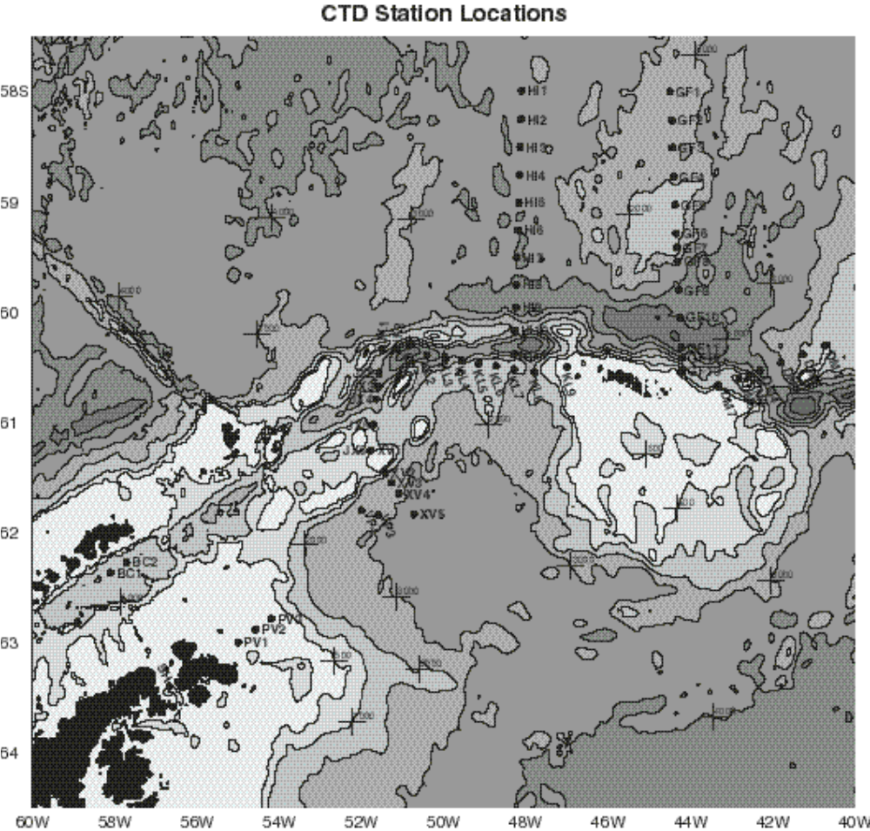
Figure 3.2-1 Station map of the first leg of the E-DOVETAIL cruise
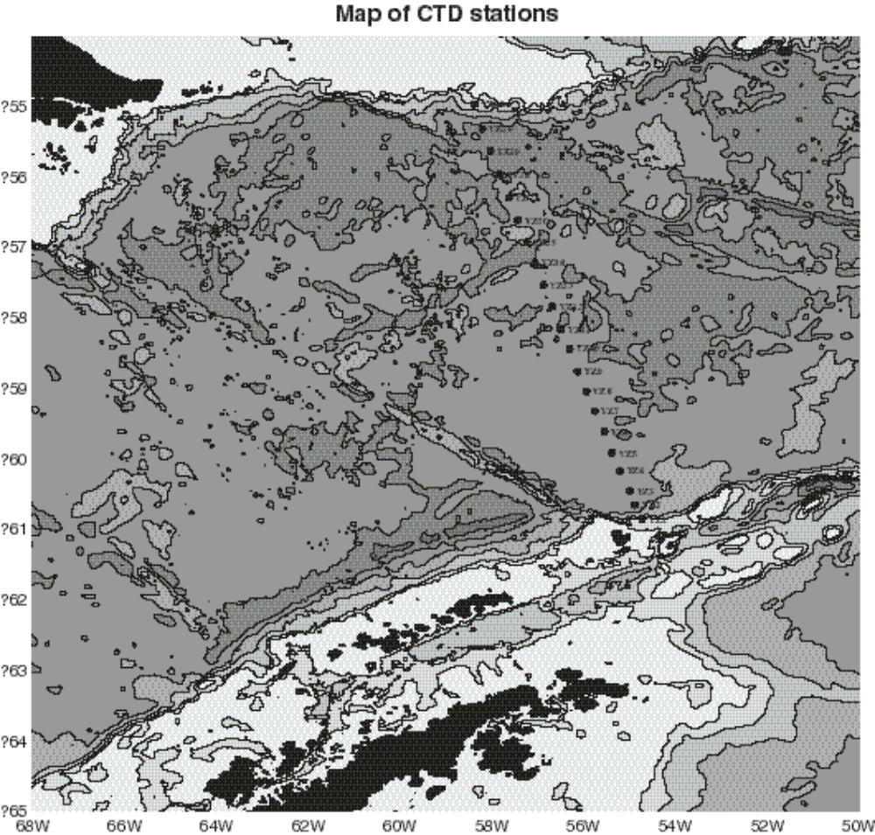
Figure 3.2-2 The second leg of the E-DOVETAIL cruise between Elephant Island and Burdwood Bank.

At the Mar del Plata iAnZone meeting, the physical oceanography results of the E-DOVETAIL cruise were presented. The outflow of dense Weddell Sea intermediate waters into the Scotia Sea west of the South Orkney plateau was well represented by the E-DOVETAIL results and a rough transport estimate was made for this outflow. Neutral density computations ascertained that the outflow hits the bottom at a latitude of about 58ºS on 48ºW. Discussion with other DOVETAIL partners helped to clarify the interpretation of the cruise results on the Bruce Bank-Laurie Island section east of the South Orkney plateau. After the meeting, plotted property sections were provided to Hartmut Hellmer from AWI at his request.

Contribution of the "Polarstern"-cruise ANT XV/4 to the DOVETAIL project
Eberhard Fahrbach
The outflow in the western Weddell Sea consists of near surface, intermediate and deep components. The near surface water are to a large extent shelf water from the Weddell Sea, which encounters in the area of the Weddell-Scotia Confluence waters from the Antarctic Circumpolar Current ( Figure 3.2-3). The confluence gives rise to a system of two fronts, the Weddell and the Scotia Front, which enclose a water mass whose properties result from the mixing of the converging water masses and the local atmosphere-ice-ocean interaction. This water crosses the ridge system in intermediate depth and might sink along the front. By this process it could contribute to the ventilation of the deep global ocean withouth ever having been bottom water in the Weddell Sea, the traditionally assumed ventilation area. The intermediate components consist of the upper part of the Weddell Sea Deep Water, which is found in the central Weddell Sea below 1250 m. In this depth level outflow is possible over large parts of the South Scotia and the North Weddell Ridges. The deep components of the Weddell Sea water flow along the South Scotia Ridge to the east and escape through gaps to the north where they fill the deep basins of the Atlantic and Indian Oceans
The work at sea during "Polarstern"-cruise ANT XV/4 from 28 March to 21 May 1998 consisted of measurements using a CTD-probe (Conductivity and Temperature with Depth) connected to a water sampler , and both ship-borne and lowered ADCPs (Acoustic Doppler Current Profiler). To obtain time series five moorings were recovered and four conventional and six expendable moorings were deployed ( Figure 3.2-4). The moorings are maintained in cooperation with the Universitat Politecnica de Catalunya in Barcelona, Spain. For details see cruise report (Fahrbach, 1999).
To measure the outflow in the northwestern Weddell Sea into the Weddell-Scotia Confluence a hydrographic section from Joinville Island to the southeast was carried out with 28 stations (Figure 3.2-5). This section represents the fifth repeat since 1989. To determine the water mass properties in the Weddell-Scotia Confluence two quasi-meridional hydrographic sections with 39 Stations were carried out one east of the South Orkney Islands (Figure 3.2-6) and the other one west of them (Figure 3.2-7). Across the northern boundary of the Powell Basin towards the Scotia Sea along the South Scotia Ridge a section with 7 CTD-stations was carried out (Figure 3.2-8), six expendable which all failed and one conventional mooring were deployed.
The measurements on the section off Joinville Island in the outflow from the southern Weddell Sea into the Weddell-Scotia Confluence (Figure 3.2-5) display comparable features with those observed during the earlier surveys. The surface waters are corresponding to the autumnal situation relatively warm. However, the thermocline from the Winter Water to the Warm Deep Water is deeper than observed in 1996. For this reason a temperature decrease is found in this layer around 500 m. The depression of the thermocline at the boundary of the gyre corresponds to an intensification of the boundary current. The temperature of the Warm Deep Water above the upper continental slope increased by as much as 0.1 K since 1996. This warming trend is not found between stations 16 and 19, where the complete water column except of the surface water is colder than in 1996. This is consistent with an intensification of the boundary current, because in this area, it is deflected into the Powell Basin. The Weddell-Sea-Bottom-Water layer on the slope is subject to strong spatial variation. Therefore a trend analysis requires further effort.
The two quasi-meridional sections east and west of the South Orkneys across the Weddell-Scotia-Confluence ( Figure 3.2-6 and Figure 3.2-7) indicate, that the band of Warm Deep Water with temperatures above 0.6°C penetrates into the Powell Basin and recirculates along the continental slope of the South Orkney Islands to the southeast. The temperature increase in the Warm Deep Water is clearly visible between stations 19 and 21, because there, the section reaches the southern part of the boundary current which has made its way through the Powell Basin and follows the southern continental slope. On the eastern section the current band is located between stations 34 and 38 (Figure 3.2-6).
Across the ridge pointing from Joinville Island to the east, Weddell Sea Bottom Water enters the Powell Basin and fills the near-bottom layers with water colder than -1°C (Figure 3.2-7). Comparable temperatures occur on the section off Joinville Island on the continental slope below 1000 m, but are not observed at all on the section east of the South Orkney Islands. There, the coldest temperatures of -0.8°C appear on the foot of the continental slope. On the northern boundary of the Powell Basin to the Soctia Sea near bottom water in depths of approximately 1500 m reaches only temperatures of -0.3°C (Fig. 6). We conclude that shallower parts of the bottom water enter the Powell Basin and leave before the western end of the Powell-Basin-boundary section. Consequently there is direct outflow of bottom water into Bransfield Strait.
The parts of bottom water colder than -1.0°C between 1500 and 3000 m, which appear on the section off Joinville Island, can not be observed further to the north or further to the east. Because they are deeper than the sill, they have to be modified by mixing. The spreading of the isolines on the slope of the Powell Basin (Figure 3.2-7) suggests that bottom water which is injected into that basin along the slope mixes with adjacent water masses. Consequently the water mass found in the Powell Basin with temperatures around -0.3°C contains a significant amount of Weddell Sea Bottom Water. This water mass fills the southern slope of the trench north of the Powell Basin to a depth of 5000 m. We conclude that a significant part of this water originates from the Powell Basin and consequently Weddell Sea Bottom Water leaves the Weddell Sea as a relative shallow water mass through the Powell Basin. However, it is dense enough to fill the deep basins of the South Scotia Trench. Because the temperature of the Warm Deep Water decreases in that area towards north it has to originate from the Weddell Sea.
Fahrbach, E., 1999: Cruise Report ANT XV/4. In: The Expedition ANTARKTIS XV/4 of the Research Vessel "POLARSTERN" in 1998. Fahrbach, E. (Ed.). Ber. Polarforsch., 314, 1-109.


Figure 3.2-3 Schematical representation of the water mass circulation and location of the hydrographical stations in the northwestern Weddell Sea. ACC: Antarctic Circumpolar Current; SACCF: Southern Front of the ACC; SF: Scotia Front; WF: Weddell Front; WSC: Weddell-Scotia Confluence; blue arrows: Weddell Sea Bottom Water (θ<-0.7°C); purple arrows: Weddell Sea Deep Water (-0.7°C<θ<0°C); red arrows: Circumpolar Deep Water (θ <0°C).
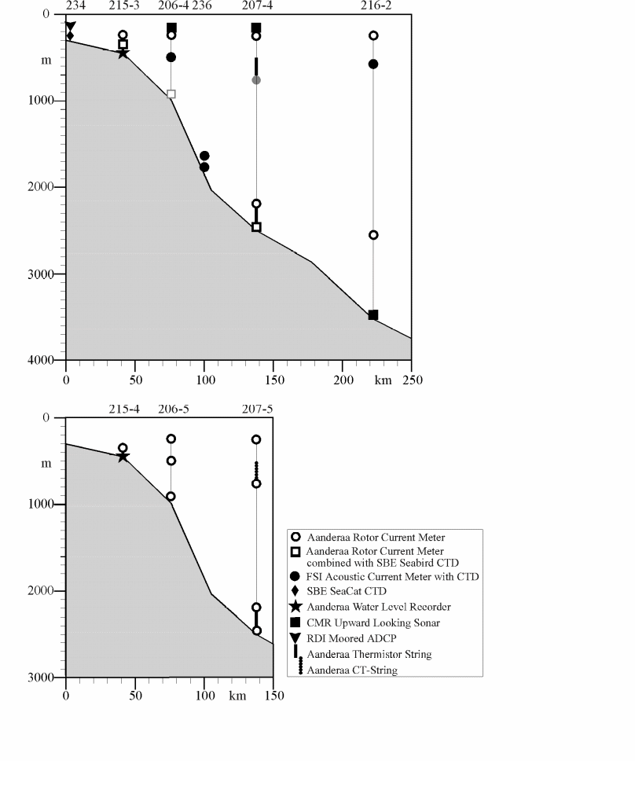
Figure 3.2-4 Vertical section across the southern Weddell Sea off Joinville Island with the recovered moorings (top) and the deployed ones (bottom).
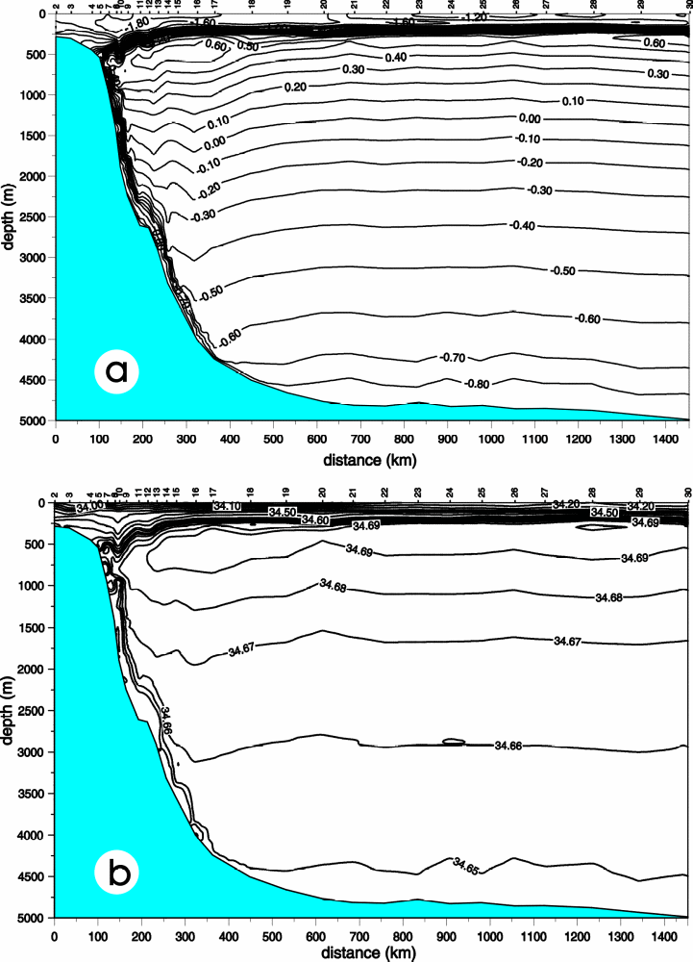
Figure 3.2-5: Vertical section of potential temperature (a) and salinity (b) across the northwestern Weddell Sea from Joinville Island to the southeast.
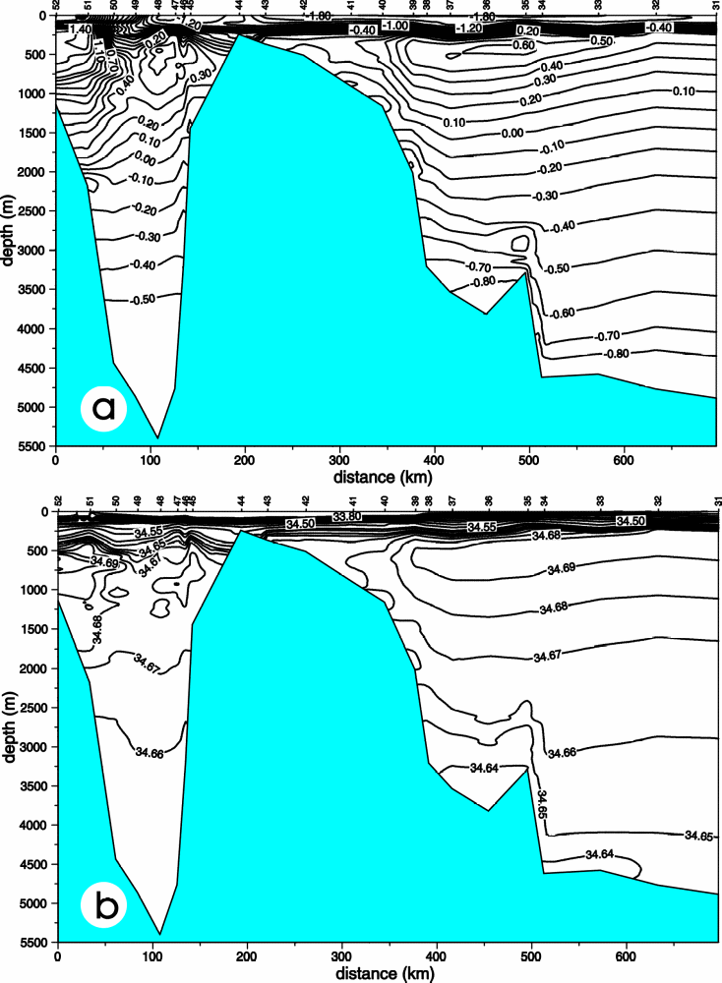
Figure 3.2-6:Vertical section of potential temperature (a) and salinity (b) across the Weddell-Scotia Confluence from 64°44'S, 39°15.0’W to 59°15’S, 44°40'W.
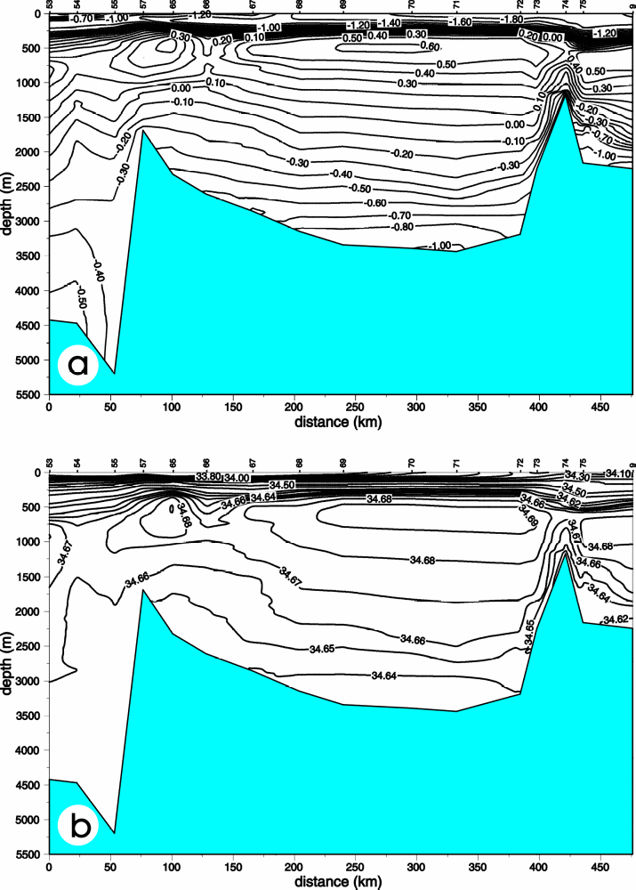
Figure 3.2-7: Vertical section of potential temperature (a) and salinity (b) across the Weddell-Scotia Confluence from 59°49'S, 48°13.5’W to 63°16’S, 50°26'W.
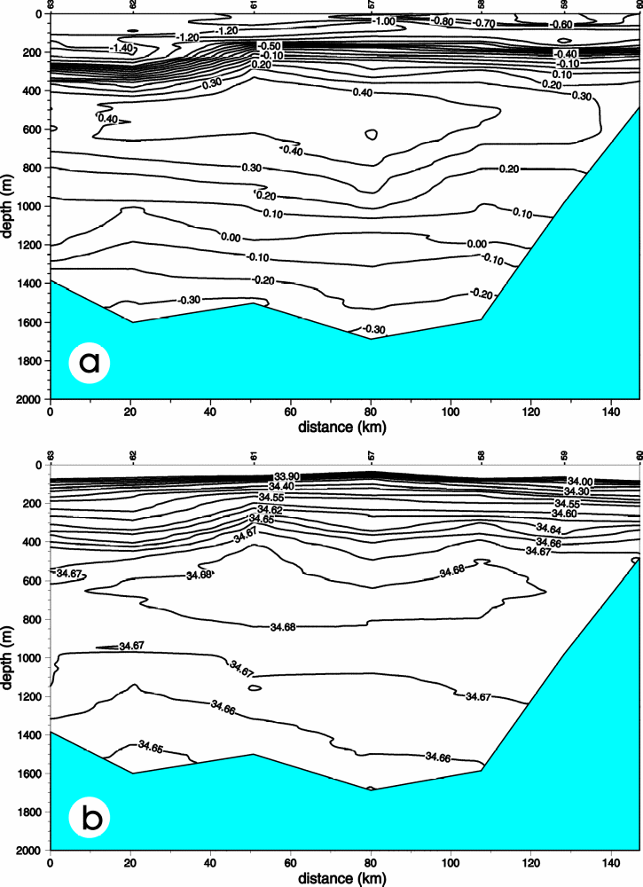
Figure 3.2-8: Vertical section of potential temperature (a) and salinity (b) along the northern edge of the Powell Basin from 60°30'S, 47°25’W to 60°38’S 50°00'W.

UK Contribution to DOVETAIL: ALBATROSS: Antarctic Largescale Box Analysis and The Role Of the Scotia Sea
Karen J. Heywood
This cruise formed the basis of the ALBATROSS project, funded by the UK Natural Environment Research Council. It was led by Dr Karen Heywood and Dr David Stevens of the University of East Anglia, UK. It took place on the RRS James Clark Ross, an ice strengthened vessel operated by the British Antarctic Survey, and is also known as JR40. We left Port Stanley, Falkland Islands (Malvinas) on 15th March 1999 and returned there on 22nd April 1999. A total of 170 CTDO2 small volume stations were occupied.
Although not formally a part of the DOVETAIL project, some very similar issues were being addressed and future collaboration is foreseen in combining the complementary data sets. During ALBATROSS we completed a closely spaced hydrographic section along the top of the South Scotia Ridge, from the Antarctic Peninsula eastwards. This essentially followed the Weddell Scotia Confluence as far east as 35W. We sampled the deep outflows from the Weddell Sea, including the Orkney Passage.
Using the Lowered ADCP data together with the CTD and tracer data (CFCs, dissolved oxygen and nutrients), we are calculating transports of water mass layers across this southern section, paying particular attention to the Weddell Sea Deep water. Since the ALBATROSS cruise was a closed box, we are also analysing the flows into and out of the box, and are implementing a box inverse model.
Further details of the cruise, including a cruise track and station positions, can be found on:
[URL 4] http://www.mth.uea.ac.uk/ocean/ALBATROSS/

Results from other international and national programs

Argentina
M. Drabble
Instituto Antártico Argentino
Cerrito 1248
1010 Capital Federal
Argentina
Ph. 0054 011 4 81220199/8120071/8120072
Fax: 0054 011 4 8122039
In the Dept. Ciencias del Mar of the Instituto Antártico Argentino two projects relevant to iAnzone are carried out:

DINOCEANTAR
It stands for DINámica OCEánica ANTARtica (Antarctic Ocean Dynamics). The objective of the project is to increase the knoweledge on tide and current dynamics of the seas surrounding the Antarctic Peninsula (northern Bellingshausen Sea, Gerlache Strait, Bransfield Strait and northwestern Weddell Sea) by means of direct tide and current measurements (see Figure 4.1-9 and Table 4.1-1 and Table 4.1-2 )
Main Investigators: Michael Roderic Drabble, José Francisco Gallo
Technical contact: Michael R. Drabble
E-mail addresses: oceano@abaconet.com. michaeldrabble@mail.abaconet.com.ar
Ph: 0054 011 4 8152642

OCEANOGRAFIA COSTERA
Coastal oceanography. The objective is to study the water dynamics of coastal areas in the South Shetland Is. and western coast of the antarctic peninsula.
Type of data: Time series of current and tide. Wind speed and direction. Mostly during summer season.
Main Investigators: José Francisco Gallo, Michael Roderic Drabble. Technical contact: Michael R. Drabble
Table 4.1-1 Current Stations of Project DINOCEANTAR
Name | Start. Date | Depth | Rec. Length
GS | 10 Dec 90 | 50 m | 32 days
GC | 17 Jan 91 | 105 m | 28 days
GN | 06 Jan 92 | 600 m | 30 days
BR | 08 Jan 96 | 700 m | 33 days
BS | 03 Jan 98 | 270 m | 30 days
 | 03 Jan 98 | 420 m | 30 days

Table 4.1-2Tide Stations of the Project DINOCEANTAR
Name | Rec. Length
PC | 75 days
HM | 30 days
LR | 30 days
PH | 30 days

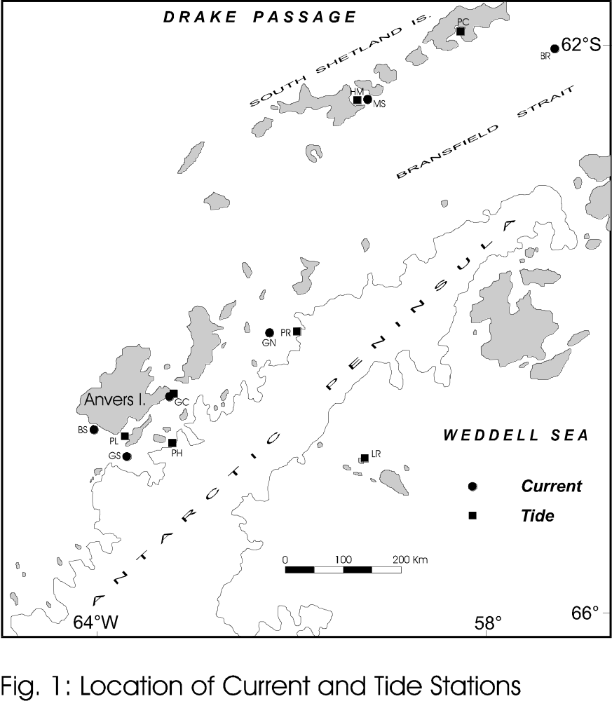
Figure 4.1-9

Australia
S. Rintoul, CSIRO
Recent and planned activities by Australian scientists of interest to iAnZone are shown in Figure 4.2-10.The primary field program carried out by the Australian program in 1998-1999 was a multidisciplinary study of the Mertz Polynya (near 145°E) in winter. The principal investigators included Ian Allison, Nathan Bindoff, Vicky Lytle, and Steve Rintoul from the Antarctic CRC, and Jim Richman from Oregon State University. The experiment got off to a "fiery" start, with the first attempt in July 1998 aborted as a result of a serious engine room fire as the Aurora Australis was about to enter the polynya. The second attempt in July 1999 was much more successful.
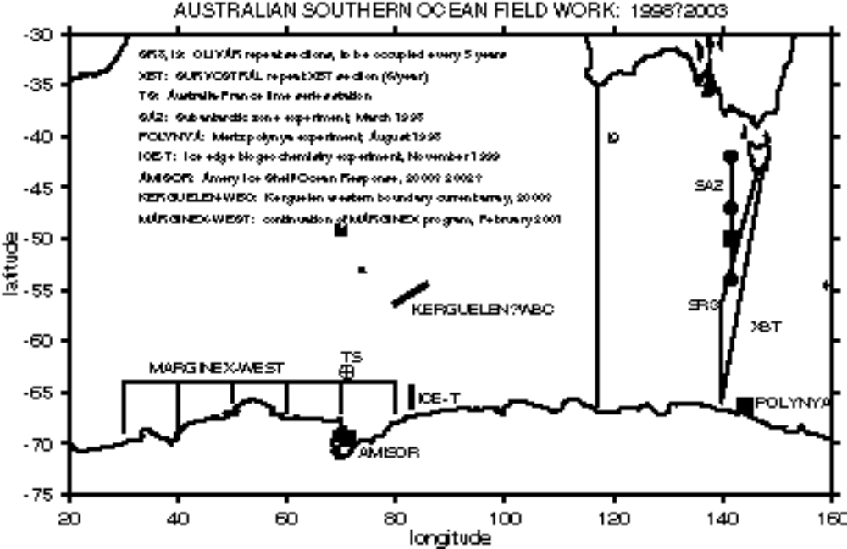
Figure 4.2-10 Australian Antarctic Programs
The overall goals of the experiment are to (1) quantify the full three-dimensional suite of atmosphere-ocean-ice (AOI) interactions within polynyas, and their spatial-temporal variability; and (2) link the AOI interactions to the effects of coastal polynyas on the sea ice distribution and water mass modification in their vicinity. The impact of the polynya on biological processes will also be studied. A third goal is to develop and validate various parameterization schemes so that polynyas can be more accurately represented in large-scale numerical simulations of the Earth's air-ocean-ice system.
To address these goals, the experiment included oceanographic, sea ice, biological, and meteorological measurements. Moored measurements of currents, temperature and conductivity were made within the polynya and across a trough through which dense waters formed in the polynya are believed to exit the shelf. All moorings were successfully recovered in February 2000, with excellent data return. A line of CTD stations enclosing the polynya was repeated several times during the experiment. Sea ice measurements included remote sensing from aircraft and satellite, drifting buoys, and drilling of ice and snow cores. Meteorological measurements included two automatic weather stations, drifting met buoys, radiosonde deployments, and radiometer and humidity measurements from ship and aircraft. The biology program addressed all trophic levels, from microbiology to whales.
Future work:
The next major field program for Australian scientists is the Amery Ice Shelf - Ocean Response (AMISOR) experiment, planned for 2000 and 2001. The AMISOR field work will include glaciological observations, water column profiling through holes in the ice shelf, CTD observations across the front of the ice shelf, and moored observations of temperature, conductivity, and currents. Modeling of the ice sheet and interactions between the ice sheet and the underlying ocean will continue. Other planned studies of interest to iAnZone include repeats of WOCE hydrographic sections SR3 and I9, which will cross the Antarctic slope and shelf. We also plan to deploy a current meter array (with Japanese collaboration) on the eastern flank of the Kerguelen Plateau to measure the deep western boundary current there.

Brazil
Carlos A. E. Garcia and Hartmut H. Hellmer
University of Rio Grande, Rio Grande RS, Brazil & Alfred-Wegener-Institute for Polar and Marine Research, Bremerhaven, Germany
Contributing to the DOVETAIL project, the University of Rio Grande in cooperation with the Alfred-Wegener-Institute will use the Brazilian RVIB "Ary Rongel" for a hydrographic survey along the western South Scotia Arc and the northwestern Weddell Sea ( Figure 4.3-11) during the period 23 January - 12 February, 2000. It is planned to conduct 64 full-depth CTD (SeaBird 911+) stations together with water sampling for salinity calibration, and for a biologic program studying phytoplankton growth and optical properties of seawater as part of ground truthing for the ocean color remote sensing program (SeaWiFS). If sea ice conditions allow, attempts will be made to recover mooring AWI 207-5 (tip of Antarctic Peninsula) which represents a cooperation between AWI and Laboratori d'Enginyeria Marítima (LIM/UPC), Barcelona, Spain.
The Brazilian agency PROANTAR made funds available to support this program for the seasons of 2001 and 2002 with the option of continuation for another 2 years.

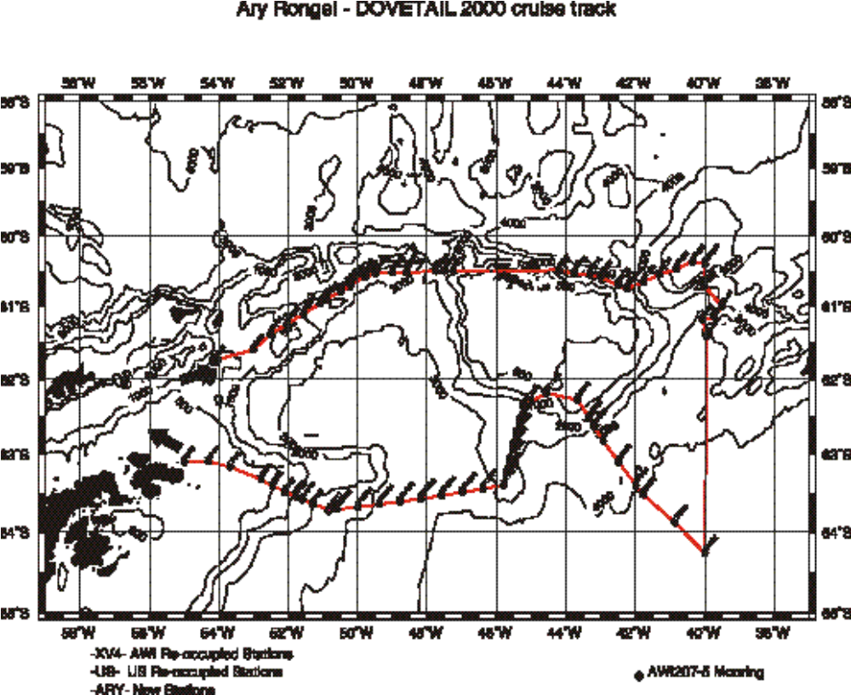
Figure 4.3-11 ARY RONGEL DOVETAIL 2000 cruisetrack

China
Zhaoqian Dong
Polar Research Institute of China
Shanghai 200129, China
Introduction
The Fifteenth Chinese National Antarctic Research Expedition (CHINARE-15) including a marine science program was successfully carried out within and outside of the Prydz Bay from December 1998 to January 1999 by ice breaker Xuelong under very heavy ice conditions.
Data obtained
Prydz Bay region:
The field oceanographic investigations covered an area of 62 ⁰-69 ⁰30'S and 70 ⁰15'-75 ⁰15'E in the Prydz Bay region, the Southern Indian Ocean. Twenty nine reached-bottom CTD stations were occupied in the working region using MARKIII CTD system. Besides the CTD measurements, ADCP was working well in the whole investigation area. Measurements of trace matters were also carried out in the area. And a bottom-mooring sediment trap with current meter was released in a point of approximately 62 ⁰S, 73 ⁰E, which is a cooperative program between the Polar research Institute of China (PRIC) and Maine University, USA, and it will be recovered in the 1999/2000 Antarctic field season. Furthermore, twenty four hour continuous observations were carried out at two oceanographic stations of 65 ⁰S, 73 ⁰E and 69 ⁰S, 73 ⁰E.
XBT/XCTD observations
There were two XBT and XCTD sections completed, one of which was from 37 ⁰S to 66 ⁰ S between Fremantle, Australia and the Chinese Zhongshan Station (69 ⁰22'S, 76 ⁰23'E), another of them was from 90 ⁰E to 140 ⁰E along sea ice edge between the Chinese Zhongshan Station to Hobart, Australia, under the Pilot Program on US - China Long Term Monitoring of the Southern Ocean, implemented by the Polar Research Institute of China and Lamont-Doherty Earth Observatory, Columbia University and supported by the NSF, USA and the Chinese Arctic and Antarctic Administration (CAA). All together, data of sixty XBTs and 12 XCTDs were obtained
Research topics underway
Data is under processing and the following topics of research is underway:
- Interaction between water masses on continental shelf of Prydz Bay and in the deep ocean north.
- Is there any Antarctic Bottom Water formed from Prydz Bay?
- Is there any convection outside the Amery Ice shelf, and what is its relation to the polynya formed during austral winter and early spring there?
- Horizontal circulation in and north of Prydz Bay.
- Upper ocean conditions of Temperature and salinity in the two XBT/XCTD sections.

Finland
Wedddell Sea Activities by the Finnish Institute of Marine Research
Jouko Launiainen, Juha Uotila and Timo Vihma
Finnish Institute of Marine Research, Box 33, FIN-00931, Helsinki. Finaland

Current activities
FIMR continued the sea ice kinematics and dynamics and air-ice-ocean energy exchange studies. They were based on measurements from drifting marine meterorological satellite buoys and automatic ship weather station and meteorological sounding data, and on comparisons of the measured data with GCM (General Circulation Model) fields. The latter ones read the ECMWF and NCEP/NCAR models. The buoy data were based on 12 buoys, during 1990-1997 totally. Additionally, ship data from three Finnish expeditions, in 1990, 1992 and 1996, were used.
Recent results of the studies of sea ice kinematics and dynamics are reported by Uotila et al . (1999). Wind forcing on ice drift, differential kinematic parameters (divergence, vorticity, shearing rate) and air-ice-ocean drag partitioning were considered for the central and eastern Weddell Sea based on buoy data from 1996. Additionally, annual sea ice export from the Weddell Sea was estimated. This was done by using the discovered dependence of the ice drift on the geostrophic wind (from the ECMWF pressure analyses fields), by the satellite derived ice concentration, and, by the ULS ice thickness data by Strass and Fahrbach (1998). Annual mean for 1996 was 50 000 cubic metres per second, approximately. This corresponds to an effective ice thickness production of 1.3 m in the Weddell Sea.
In a report by Vihma et al. (1999), various air-ice-sea energy exchange quantities were studied. Those were made both by using meteorological data from the buoys and the thermodynamic air-ice-ocean model by Launiainen and Cheng (1998). Addtionally, meteororological observations, and fluxes derived from those, were compared with the GCM- field values (European ECMWF, NCEP/NCAR from USA), interpolated for the site. Both the meteorological quantities and the fluxes derived from the model fields were found to be still rather inaccurate for the area. For wintertime freezing weather, ECMWF yielded significantly too high surface temperature and 2m air temperature, whereas NCEP/NCAR estimated too low temperatures compared with the observed temperatures by the buoys. Typically, ECMWF value was 3 to 5 centigrades too high and NCEP/NCAR 3 to 8 centigrades too low compared with the observations ( Figure 4.5-12 and Figure 4.5-13). The mutual difference in the signs shows that the reason for the biases can not be in erroneus buoy observations. As to ABL quantities others than the air (or ice surface) temperature, the results differed less from the observations. However, the kind of differences in the surface and air temperatures cause significant errors e.g. in air-sea-ice flux calculations.

Future plans
FIMR plans to continue the air-ice-ocean energy (heat and momentum) studies in the Antarctic seas. In addition to observations and modelling for verification and improvement of area-representative considerations for GCMs, polynya and MIZ studies earn to get more attention. The above reflects that our studies are closely related to goals and studies planned in the program ASPeCt/SCAR.
Accordingly, our contribution should be most relevant in the boundary layer air-ice-ocean studies. In practice, this would mean local and mesoscale ice studies, buoys, flux and radiation measurements, balloon soundings etc.. Based on those and proper local and meso scale modelling, we should be able to give a contribution to estimation of exchange of energy related to loss of buoyancy and convection in the ocean.
As to experiments, no discrete planning has yet been made. One possiblity would be that, say in 2002 or 2003, we would use our own vessel. She is well equipped but small and cannot without "a safe guard" go deep into a pack ice. However, in proper polynya region and/or in MIZ our RV Aranda can do the air-ice-sea work and all kind of ocean works. In addition to our group, we may offer room at least for 10 foreign scientists. Nevertheless, a case if the iAnZone #4 experiment will be in the Ross Sea, the area may be "too remote" for us. Another possibility viewed might be that we would join with another expedition round 2002-2004 (Australian, German). The above ideas were very preliminary cast in ASPeCt/SCAR meeting in Monterey, in March,1999.
Generally, we find that a close co-operation between ASPeCt and iAnZone should be motivated and fruitful at least as to field operations. One such issue would be a common drifting ship experiment. We would be interested in participating in a such one.
References:
J. Uotila, T.Vihma, and J. Launiainen: Response of the Weddell Sea pack ice to wind forcing, 1999. - Accepted to JGR
T. Vihma, J. Uotila, B. Cheng, and J. Launiainen, 1999: Surface Heat Budget over the Weddell Sea: Buoy results and comparisons with large-scale models. - Submitted to JGR
J. Launiainen and B. Cheng: Modelling of ice thermodynamics in natural water bodies. Cold Reg. Sci. Techn. 27, 153-178, 1998.,
Strass, V.H., and E. Fahrbach: Temporal and regional variation of sea ice draft and coverage in the Weddell Sea obtained from upward looking sonars, in Antarctic Sea Ice: Physical Processes, Interactions and Varability, Antarctic Res. Ser., 74, 123-139,1998.
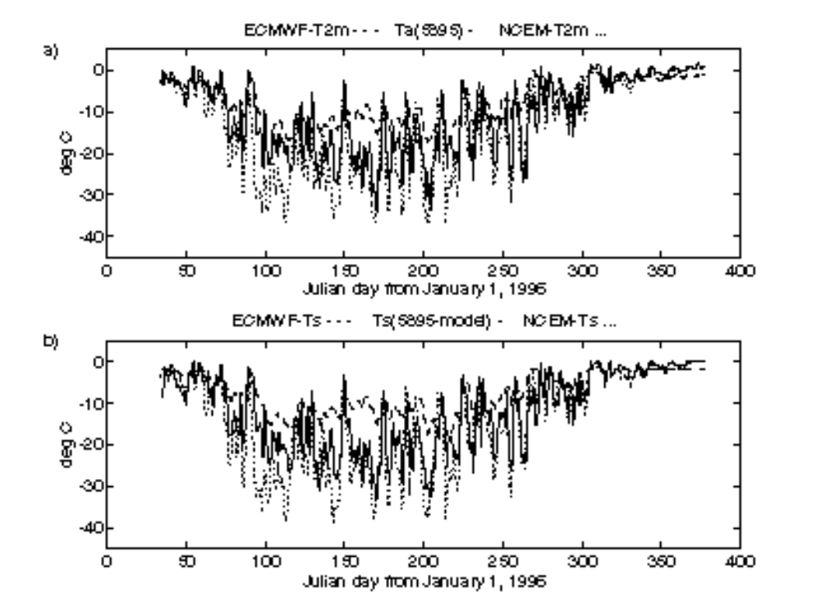
Figure 4.5-12Time series of (a) 2-m air temperature according to the buoy (solid line), ECMWF model (dashed line), and NCEP/NCAR model (dotted line), and (b) the surface temperature according to the buoy, and the ECMWF and NCEP/NCAR models. (From Vihma et al. (1999)).
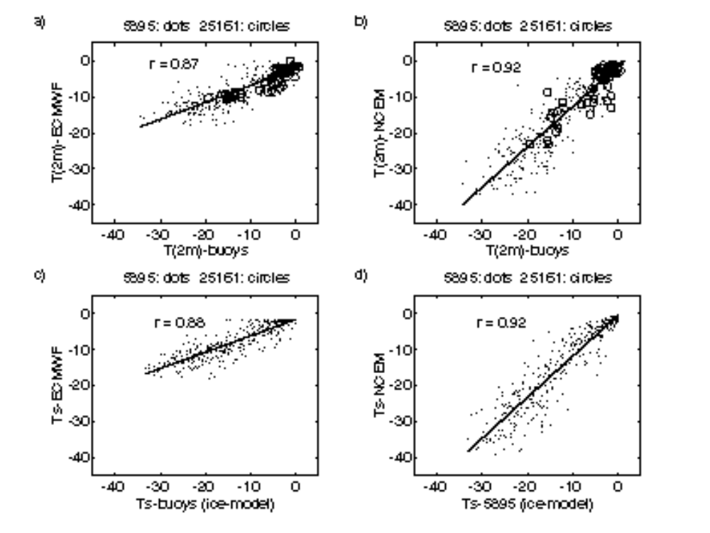
Figure 4.5-13. Comparisons of the buoy and model temperatures, for (a) buoy and ECMWF 2-m air temperatures, (b) buoy and NCEP/NCAR 2-m air temperatures, (c) buoy and ECMWF surface temperatures, and (d) buoy and NCEP/NCAR surface temperatures. The buoy surface temperatures are based on the application of the thermodynamic ice model. (From Vihma et al. (1999)).

Germany (with FRISP/ROPEX contributions from Norway, U.K. and U.S.A. )
E. Fahrbach
The German activities comprise fieldwork and related modelling efforts. The field work refers to different subprograms which all contribute to a better understanding of the deep and botttom water formation in the Weddell Sea, its time variability and its role in the large scale overturning of the global ocean. Some contributions to the report are given under different topics.

Fieldwork
1. The contribution to DOVETAIL is presented under contribution to "iAnzone projects".
2. The contribution to FRISP is presented in the international context with contribution from Norway, U.K. and the U.S.A..
3. The contribution to Convection and future plans are presented under the topic "Status of Convection".

Contribution of the "Polarstern"-cruise ANT XV/4 to the FRISP/ROPEX-Project
Report provided by Eberhard Fahrbach, Alfred-Wegener-Institut für Polar- und Meeresforschung, Bremerhaven.
The processes which determine the interactions between the glacial ice and the adjacent sea water are studied since 1983 in the framework of the Filchner Ronne Ice Shelf Program (FRISP) sponsored by the Scientific Committee on Antarctic Research (SCAR). In this framework an international investigation occurred in the southern Weddell Sea as a cooperation between the AWI, Germany, the British Antarctic Survey, U.K., the Geophysical Institute in Bergen, Norway and Earth and Space Research, Seattle, USA. It is the objective of this work to quantify the transport of Ice Shelf Water into the deep sea using direct measurements of the currents made with moored instruments. The mixing of the Ice Shelf Water with the lighter surrounding water determines the depth to which the outflow can sink. This can be derived from the temporal fluctuations of the Ice Shelf Water flow, that are measured with the moored instruments, and the spatial distribution, that can be learnt from the CTD sections. For this project, four moorings were placed in the outflow in 1998 by "HMS Endurance" during the ROPEX 1997/98 cruise and recovered by "Polarstern" during ANT XVI/2 from 9. January to 16. March 1999.
At the northern sill of the Filchner Trough Ice Shelf Water drains into the deep sea. This water mass forms because water of high salinity flows in beneath the ice shelf. At a depth of 1000 m, the freezing point of seawater is lowered to -2.5°C. As a result the inflowing water, even if it has already reached the freezing temperature at the sea surface, can be further cooled at the base of the ice shelf through melting. In this manner, the coldest water found anywhere in the ocean is formed. Part of this supercooled water freezes at the underside of the ice shelf on its way back out, so forming marine ice. Another part comes out at the front of the ice shelf as supercooled water. In the Filchner Trough it flows to the north, where with a temperature of -2.1°C it crosses a low saddle at the edge of the continental shelf, and as a result of its high density, caused by its low temperature, drains into the deep sea. This outflow contributes to the formation of Weddell Sea Bottom Water, which feeds into the circumpolar ocean to the north, from where it flows further into the three ocean basins as Antarctic Bottom Water.
The oceanographic work carried out by "Polarstern" in 1999 comprised three major CTD sections ( Figure 4.6-14). In October 1998 the iceberg A-38 with the German Filchner summer station broke off from the shelf ice which required significant changes of the program. A team of specialists had to be brought to the iceberg and "Polarstern" had to operate in the area until the personal and the dismantled station could be taken on board. The ice conditions were comparatively heavy so that the ship had to stay in the vicinity to assure the safety of the personal. Therefore the first CTD section was carried out from the iceberg A-38B, extending onto the continental slope, a second one in the region of the descending flow of Ice Shelf Water and a third one along the northern sill of the Filchner Trough ( Figure 4.6-14). The sections allow to trace the modified Warm Deep Water which penetrates from the deep ocean on the shelf (Figure 4.6-15) and the outflow of Ice Shelf Water from the Filchner Trough ( Figure 4.6-16) into the deep ocean where it is found on the section in approximately 2500 m depth ( Figure 4.6-15).
The recovery of the moorings ( Figure 4.6-17) was difficult due to the heavy ice conditions. The mooring F3, on the continental slope to the northwest of the Filchner Depression, was lying, at the time of the first attempt at recovery, under D11, a giant iceberg 8 nautical miles in width and 30 nautical miles in length ( Figure 4.6-14, bottom). The other three moorings and the Bottom Pressure Recorder C2 could be more easily recovered. Afterwards the Bottom Pressure Recorder M2 of the Proudman Oceanographic Laboratory was recovered within thick ice. Meanwhile, D11 had shifted sufficiently to leave F3 clear that it could successfully retrieved. The record long averaged current measurements ( Figure 4.6-17, top) suggest that currents are strongly affected by small scale bottom topography. A first evaluation indicates an annual mean bottom water flow of 1.8 Sv superimposed to which are significant fluctuations on a large range of time scales.

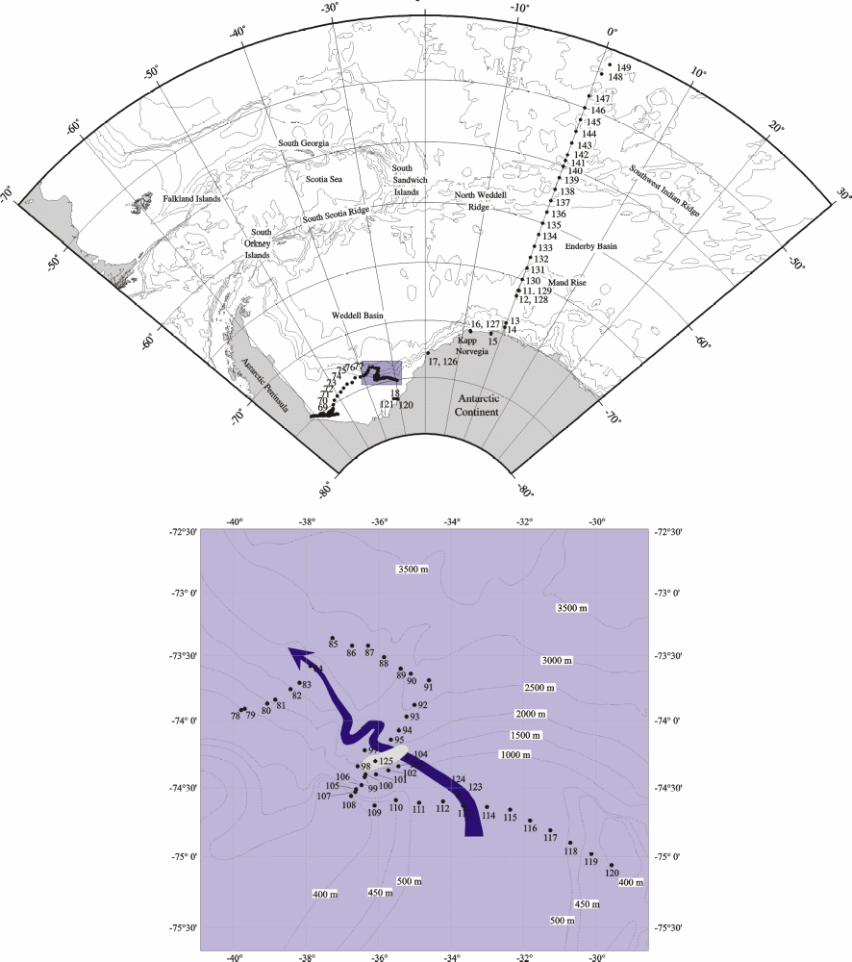
Figure 4.6-14: Location of CTD stations during "Polarstern" cruise ANT XVI/2 from 9 January to 16 March 1999 (top). The insert (bottom) gives more details on the stations along the sill of the Filchner Trough and the continental slope west of it. The flow of newly formed bottom water is indicated as a blue arrow. The iceberg D11 is displayed in the area of station 125.

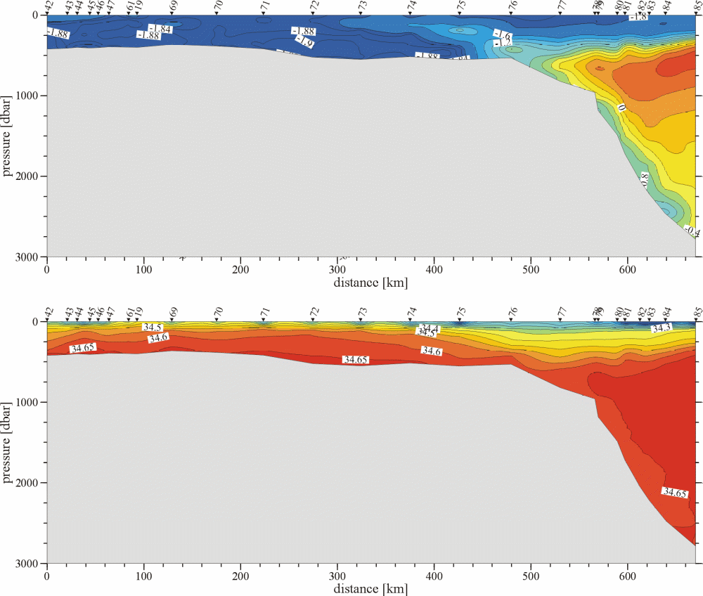
Figure 4.6-15: Transect of potential temperature and salinity from the Ronne Ice Shelf across the shelf and the continental slope into the deep Weddell Sea carried out during "Polarstern" cruise ANT XVI/2 from 9 January to 16 March 1999.

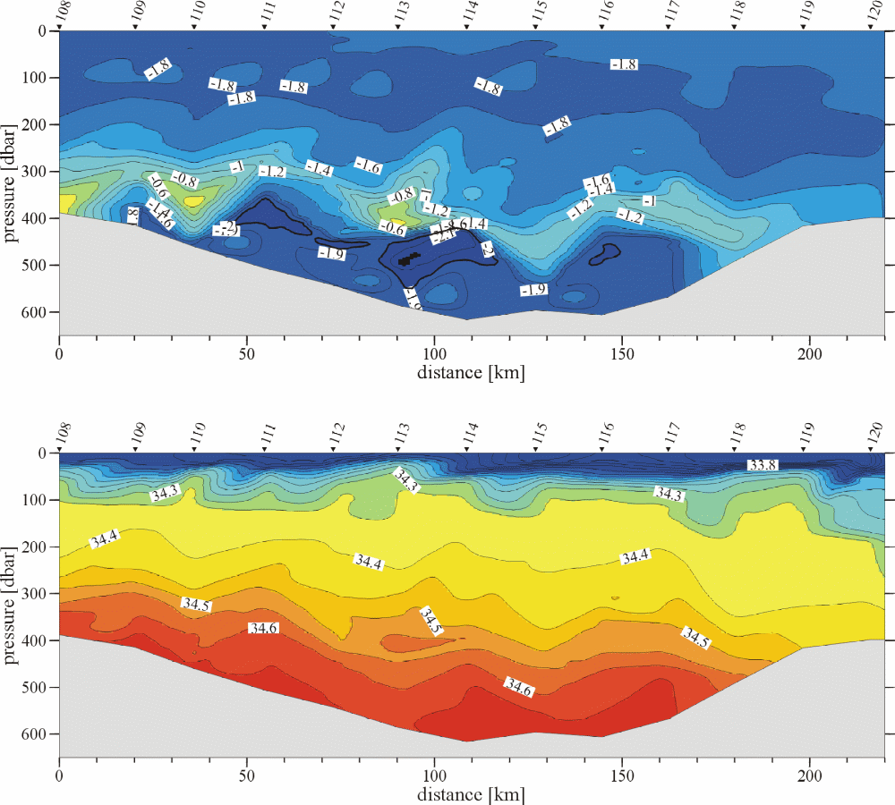
Figure 4.6-16: Transect of potential temperature and salinity along the sill north of the Filchner Trough carried out during "Polarstern" cruise ANT XVI/2 from 9 January to 16 March 1999.

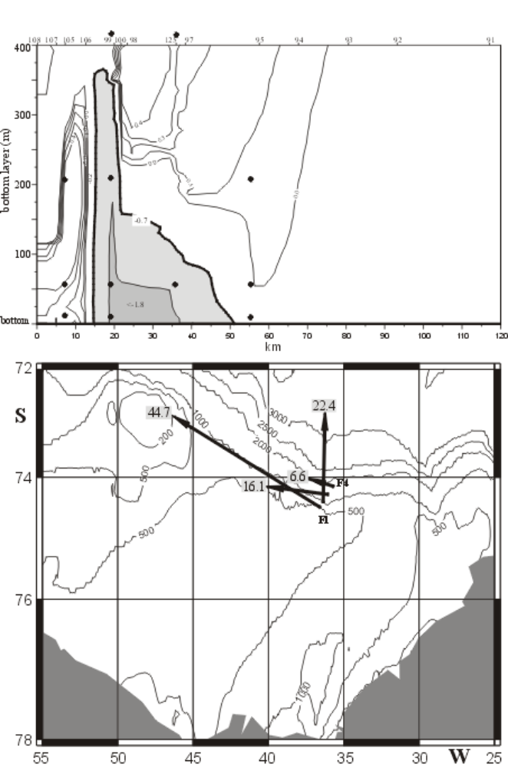
Figure 4.6-17: Locations of the current meters recovered during "Polarstern" cruise ANT XVI/2 from 9 January to 16 March 1999 at the continental slope into the deep Weddell Sea northwest of the Filchner Trough on a transect of potential temperature of the 400 m thick layer above the bottom (top) and map with the record long average currents in the near bottom layer (bottom). The current velocity is indicated in cm/s at the end of the arrows.

Modeling
Hartmut H. Hellmer and Aike Beckmann
Alfred Wegener Institute for Polar and Marine Research, Bremerhaven, Germany
At the Alfred Wegener Institute (AWI) modeling efforts focused on the Southern Ocean are manifold yet all based on the regional climate modeling BRIOS. The standard configuration has a horizontal resolution of 20-100 km in the Weddell Sea sector, embedded in a coarsely resolved circumpolar Southern Ocean south of 50°S, and 24 terrain-following levels in the vertical [Beckmann et al.,1999]. This „climate version„ of the BRIOS ocean model is forced with monthly mean surface fluxes of momentum and freshwater, and a temperature restoring to mixed layer climatology, all resulting from a stand-alone sea ice-mixed layer model (after Lemke et al., [1990]).
In the past year, this version has been used to study the overturning strength of the Southern Ocean related to the production of deep and bottom waters (see Figure 4.6-18), to determine its sensitivity to the fresh water input due to ice shelf base melting, and to define the distribution and strength of sources around Antarctica contributing to the ventilation of the deep World Ocean. Papers are in preparation or submitted to Geophysical Research Letters.
A version with a nearly constant resolution of 20 km for the Weddell Sea sector is used to study the export of water masses formed/modified in the Weddell Sea across the South Scotia Arc, and the sensitivity of this transfer to extreme climates of the 1990's in the Weddell Sea. This effort represents AWI's modeling contribution to the international DOVETAIL project. Results will be presented at the EGS Assembly Meeting, Nice, April 2000, and at the DOVETAIL Workshop, Barcelona, May 2000.
In a parallel development, the ocean model component was directly coupled to the dynamic--thermodynamic sea ice model (after Lemke et al., [1990]). Model results, soon to be presented as part of a PhD thesis by R. Timmermann (AWI), agree well with the observations of sea ice distribution and thickness in the Weddell Sea. In addition, the results show a high sensitivity of the sea ice cover, water mass characteristics and circulation to the fresh water input at the surface, a quantity difficult to retrieve with high accuracy from the (ECMWF or NCEP) reanalysis data sets.
An improved hydrological cycle in the Weddell Sea and adjacent areas has been obtained from an experiment with the nested atmospheric circulation model (REMO), which has been integrated for one year (1985). The resulting precipitation and evaporation fields are in general agreement with ECMWF data, but at higher resolution and without spectral noise. Once validated with additional in-situ observations this model will be coupled to the existing coupled ice-ocean model.
Embedded in the BRIOS framework, additional activities in the Weddell Sea address the role of topography at the continental shelf break on the generation of baroclinic tides, as well as the simulation of iceberg drift. For the latter, the relative importance of the various forces (wind, ocean currents, sea ice) acting on icebergs has been quantified. The trajectory of iceberg C7 which, in 1990, drifted within the coastal current through the whole Weddell Sea was reproduced successfully, after sea ice related forces had been included in the model.
Finally, the dependence of phytoplankton bloom on hydrographic conditions at the Polar Front of the South Atlantic is also being studied within the BRIOS context.

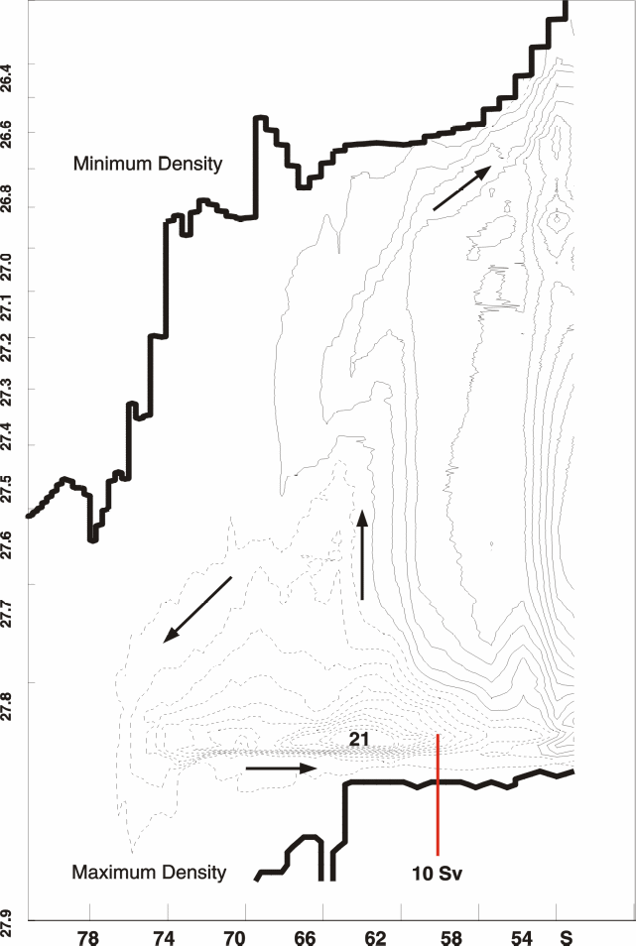
Figure 4.6-18: Overturning transport streamfunction for the circumpolar Southern Ocean as a function of potential density. The vertical scale is stretched toward higher values for a better view of the dense near-bottom flow. Dashed lines indicate counter-clockwise, solid lines clockwise circulation. The thick solid lines represent the minimum (upper) and maximum (lower) density value for each latitudinal band. Contour spacing is 2x10⁶ m³s⁻¹ starting from 1x10⁶ m³s⁻¹.

References
Beckmann, A., H. H. Hellmer, and R. Timmermann, A numerical model of the Weddell Sea: Large scale circulation and water mass distribution, J. Geophys. Res., 104, 23,375-23,391, 1999
Lemke, P., W. B. Owens, and W. D. Hibler III, A coupled sea ice-mixed layer-pycnocline model for the Weddell Sea, J. Geophys. Res., 95, 9513-9525, 1990

Italy
G. Spezie
Italian National Program of Researches in Antarctica
1999 - 2001

Estimate of energy and mass fluxes in polynya areas and in regions of mesoscale interaction between shelf and open ocean waters in the Ross Sea (C.L.I.M.A. project)
Principal investigator Prof. Giancarlo Spezie IUN - Napoli
Research Program
Over the last years the international scientific community has shown a growing interest in the study of the Antarctic region and of its interactions with the Southern Ocean. However, several aspects such as, e.g., ice formation processes and consequent water mass modification, polynya persistence, physical and biogechemical ice-sea interactions, still deserve further investigation. In the framework of the C.L.I.M.A. project, most studies have been carried out at basin scale, in order to identify the basic mechanisms and the relevant areas. In particular, the circulation in the Ross Sea (RS) has been investigated by hydrological and current measurements and by diagnostic models. The flow field within the RS has proved to be deeply affected by bottom topography, by the presence of the Ross Ice Shelf (RIS), by the water mass exchange at the continental slope and by localized formation of water masses, which represent an important component of the Antarctic Bottom Waters (AABW). The smaller scale processes which determine the physical and biogeochemical dynamics of the RS, as well as, indirectly, its role on global climate, are still to be clarified and assessed. In this perspective, along with major international projects such as WOCE, conceived for the large-scale observation of the thermal and dynamical structure of the oceans, and WCRP-IPAB, whose objective is focussed on the Southern Ocean, the scientific community has undertaken a few multidisciplinary projects dealing with meso- to small scale phenomena, such as: ASPeCT, centered on the ice-sea interaction processes in Antarctica and their climatic variability; ACoPS, which evaluates the role of Antarctic polynyas in the global ice production and in the bottom water formation.
In the formation process, a major mechanism takes place, that of water mass ventilation, which, in the framework of the proposed research, will be investigated also in its indirect effects, in addition to the evaluation of the gas transfer coefficients between ocean and atmosphere and to the determination of the age of the water masses by tracer measurements. In particular, many of the projects set in the Southern Ocean have been designed to assess the flux of CO2 between water and atmosphere, a process affected by two factors: the "biological pump" and the formation of dense water. The different levels of efficiency of the biological pump can lead to a net CO2 release into the atmosphere through respiration or, conversely, to the formation of organic matter, which, once trapped in the bottom waters, can be confined in the deep ocean circulation for decades or centuries. The increase of CO2 content in the ocean constitutes a fundamental issue for climatic studies, and it is therefore of crucial importance to assess gas fluxes between water and atmosphere through the evaluation of the piston velocity.
The functioning of an area characterized by such complex hydrodynamic and biogeochemical phenomena needs obviously to be investigated also in the framework of a numerical modelling activity at different scales and at different detail levels. Therefore, modelling studies will be undertaken taking encompassing most of the study objects of the research tasks.
Research design
The research is divided into four fundamental tasks.
i) COASTAL POLYNYA PROCESSES. Polynyas are areas where interactions among air, sea and ice are the strongest, with relevant effects on the formation of sea ice, on dense water production and on water ventilation, on biogeochemical fluxes in terms of gas exchange and vertical convection as a mechanism for carbon transport. Earlier activities within the C.L.I.M.A. project in the Terranova Bay (TB) area has produced an analysis of the hydrological and biogeochemical characteristics of the water column on the basis of a three year time series of data collected by moored instrumentation. The analysis of those data does not allow, however, for an evaluation of some crucial parameters ruling the polynya process, such as, in particular, those connected with the local meteorological forcing and by the coastal circulation, i.e. the processes at the basis of the air-sea fluxes in the polynya. The research on the TB polynya will continue to put together annual time series of data collected by moored instruments with shorter term hydrological measurements to be gathered during a summer cruise on a small scale station network just off the Bay. A major role will be played by the integration with meteorological measurements, both at basin and at local scale, with particular emphasis on turbulent flux measurements at the interface ice-sea-atmosphere, which are of crucial importance in polynya areas. Meteorological measurements will be carried out in the framework of the observatory activities, ruled by an protocol of intents. Synoptic measurements of surface currents will be moreover undertaken with a coastal observation radar system (OSCR II) provided and operated by a foreign research unit (Scott Polar Research Institute, University of Cambridge, UK).
ii) MESOSCALE FRONTAL PROCESSES ON THE CONTINENTAL SLOPE. This task is aimed at improving the understanding and modeling of the outflow processes taking place on the antarctic continental slope, utilizing both multidisciplinary measurements and phenomenological and numerical models. Earlier studies have allowed to follow the spreading of those waters up to the slope, where they undergo substantial modifications due to meso- to small scale processes in the interaction with the front generated by the presence of the Circumpolar Deep Water (CDW). These processes cannot be resolved with the spatial resolution used by the C.L.I.M.A. project in its first phase, and this has caused the past limited reliability of the flux estimate in the area. Therefore, we propose a mesoscale investigation focussed on the repeated observation of two areas, identified during the 1997-98 cruise, where analogous phenomena involving different shelf water masses (HSSW and ISW) take place. Figure 4.7-19 shows the positions of the hydrological stations and the moorings during the previous activity of the CLIMA project. In the figure we zoomed the area of the mesoscale experiment. In particular H meso 98 experiment was carried out in the Ross Sea during the XIII Italian PNRA Expedition (Jan – Feb 1998). An intensive 5 days mesoscale experiment was completed near the continental shelf break ( Figure 4.7-20), an intense mixing region from which water upwells into the surface layer, intrudes at intermediate depths onto the shelf or is entrained by downslope flows into the deep ocean. shows, for example, the distribution of T_{min} versus its depth in this area.
The formation of these waters is characterized by profoundly different interaction mechanisms at the sea-atmosphere interface. A critical parameter is constituted by the respective age of the water masses, whose assessment represents therefore on of the main goals of the proposed research. In the framework of the C.L.I.M.A. project two research units (one of which is from Lamont-Doherty Earth Observatory, Columbia University, Palisades NY, USA) will be specifically involved in this activity. Earlier measurements collected in the framework of the C.L.I.M.A. project suggest that in the slope process dynamics a role is played by density currents, triggered by density differences between the involved water masses; ad hoc analytical and numerical models will be developed to shed light on these phenomena.

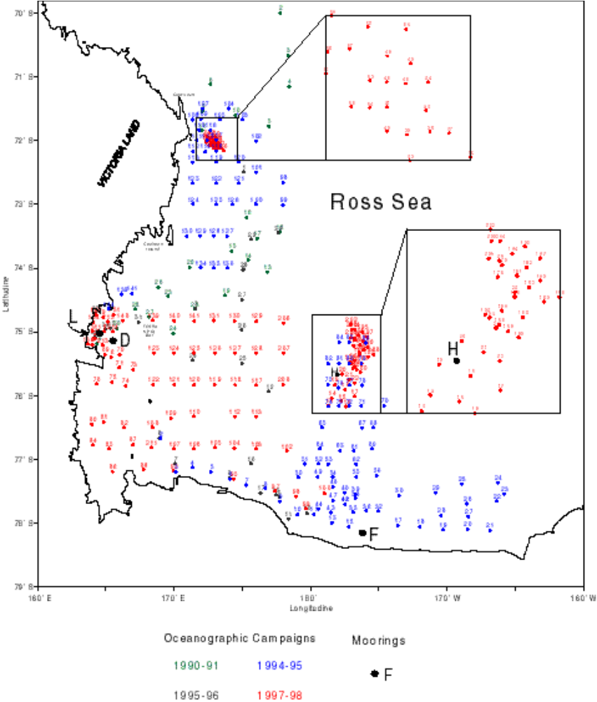
Figure 4.7-19: Positions of the hydrological stations and the moorings

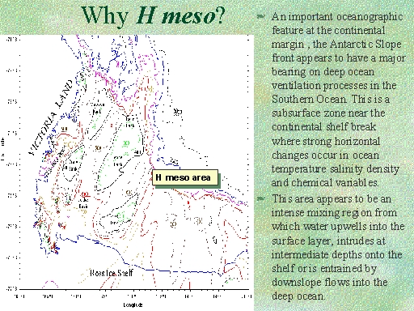
Figure 4.7-20
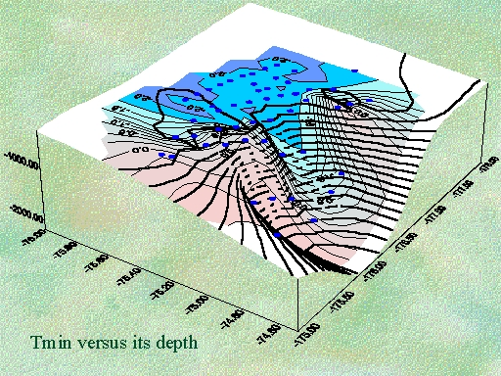
Figure 4.7-21:
iii) VARIABILITY OF THE THERMAL AND DYNAMICAL STRUCTURE OF THE PACIFIC SECTOR OF THE SOUTHERN OCEAN. We intend to continue the collection of data on the thermal structure of the upper ocean by XBTs on every ship voyage between New Zealand and the RS. The availability of at least two sections every year starting in 1994 will prove useful in the medium-long term for climatic change studies. Information on horizontal dynamics and/or variability of the Antarctic Circumpolar Current will be obtained by using remote sensing and Lagrangian surface and subsurface data. From 1995, every year during the navigation from N. Zealand to Ross Sea and return, two or more drifter were launched in the ACC. Figure 4.7-22 shows the surface drifter trajectories updated April 1999.
In the same way more than 1200 Sippican T-7 XBT were launched along the ex Woce P14 Section. Spacing between launches varied from 10 to 40 km with an increased resolution in the area in which the PF was supposed to be. As we can see by our data ( Figure 4.7-23), e.g. 94/95 and 95/96 expeditions, the SAF is not uniquely individuated, so we hypothesize in the N. Zealand area a splitting of the SAF in a northern and a southern one.

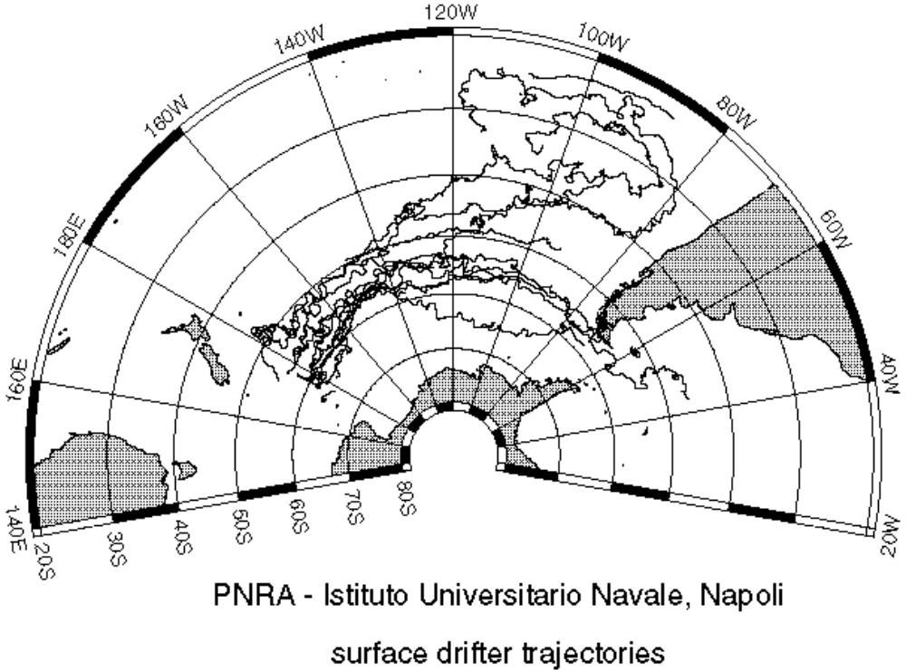
Figure 4.7-22:

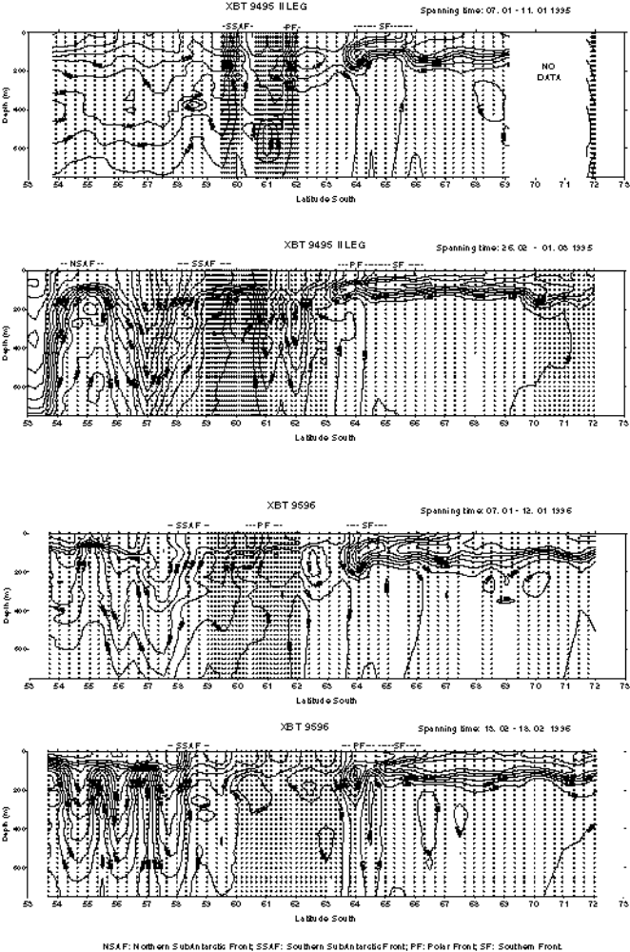
Figure 4.7-23:
iv) PHYSICAL AND BIOGEOCHEMICAL DYNAMICS OF THE SITE OF SPECIAL SCIENTIFIC INTEREST IN THE ROSS SEA. The study of coastal areas, introduced for the polynya areas, will be extended, with the necessary modifications, to the site of special scientific interest which is located South of Thetys Bay over 23.5 square km down to Adelie Cove. The monitoring and investigation of this area, whose management has been planned within a cooperation between New Zealand and Italy, have been started by the C.L.I.M.A. project during the 1997-98 cruise, when a mooring was deployed, equipped with current meters, temperature and salinity sensors, sediment traps; we will keep the mooring in the area for the whole three year period of the research, and carry out hydrological measurements to evaluate the hydrodynamical regime and the biogeochemical processes in the area.
Objectives
i.a) to characterize the physical and biogeochemical dynamics of the polynya area of Terranova Bay from time series of data collected by moored instruments and from hydrological measurements; to map the surface current field in the area and to put it in relationship with the local scale meteorological forcing.
i.b) to identify the HSSW formation in the polynya area, to characterize it in biogeochemical terms and to follow its spreading on the continental slope in the studied area.
i.c) to estimate the fraction of organic carbon which is transferred, in different forms, into the dense waters according to Legendre and Michaud's 1998 model.
i.d) to estimate the residence time of the HSSW from tracer measurements.
ii.a) to collect mesoscale observations of physical, chemical and biological variables in two areas along the edge of the continental slope of the Ross Sea: close to Cape Adare, in correspondence of the HSSW outflow, and 200 km north of the Ross Ice Shelf, in correspondence of the ISW outflow.
ii.b) to develop a model able to simulate the evolution of the chemico-physical characteristics of the two above water masses.
ii.c) to estimate the energy and mass flux of the interaction continental slope-open sea, as well as of dissolved and particulate matter, dissolved oxygen and CO2.
ii.d) to estimate the residence time of the ISW and the spreading of shelf waters by tracer measurements.
ii.e) to estimate the climatic effects of the above interaction continental slope-open sea.
iii.a) to evaluate the mass transport of theAntarctic Circumpolar Current (ACC).
iii.b) to evaluate the interannual variations of its thermal structure and of its mass transport.
iii.c) to determine the position and evolution of the fronts associated with the ACC.
iii.d) to continue the collection of the time series on the thermal structure of the ACC, started during the 10th expedition, so as to keep as long a record of its variations as possible.
iv.a) to identify the thermohaline conditions of the water masses present in the area of the SSSI and to evaluate their mixing.
iv.b) to identify the typical dynamical regimes as a function of the boundary forcing.
iv.c) to apply and validate different scale circulation models to the studied areas of the Ross Sea, of Terranova Bay and of the SSSI
Methodology
Thermal structure of the upper layer of the Pacific sector of the Southern Ocean: XBT launches every 5-30 nautical miles. Satellite infrared, altimeter and scatterometer data to yield surface temperature field, free surface variability and wind stress. Lagrangian drifters for direct information on the Antarctic Circumpolar Current and to integrate XBT and remote sensing data. Thermohaline structure of the water column: physico-chemical parameters (pressure, temperature, conductivity, salinity, pH, dissolved oxygen, fluorescence, transmittance, PAR (Photosynthetically Active Radiation), SPAR (Surface PAR)) measured by multiparametric unit. Chemical analyses on water samples: Dissolved oxygen: potentiometric titration. Nutrients: determination by continuous flow air-segmented autoanalyzer. Micronutrients: electrothermal atomic adsorption spectrometry. CFC extraction by a "purge and trap" system and determination by gas chromatography. Water mass age, spreading and residence time: by tritium, helium isotopes and stable isotopes in water. Biogeochemical analyses of suspended matter: determinations on different size classes obtained by differential filtration. Dimensional analysis of particles with a Coulter Counter Multisizer. Total suspended matter: gravimetric method; biogenic silica: spectrophotometric method; organic carbon: gas chromatographic method; chlorophyll: spectrofluorimetric method; determination of the plankton and fecal pellet carbon content using CHN analysis and linear microscopic measurements; DOC concentration; primary production: 14C method through incubation on deck; respiration rate; bacteria methabolic activity; heterotrophic activity by 3Hthymidina and 3Hleucine incorporation; grazing efficiency of nano-, micro- and mesozooplankton through dilution and incubation methods; egg production and hutching success of some dominant copepods by incubation methods. Sinking particles: time series sediment traps and transmissometers at two depths in the polynya and shelf break areas (only one in the SSSI, about 100 m depth); assessment of the total mass flux and of its biogenic components; qualitative observations with SEM and optical microscope, determination of the main phytoplanktonic species and of zooplanktonic swimmers.

Activity in Antarctica (N.O. Italica)
Jan – Feb 2000 | XBT – DRIFTERS – MOORINGS
Nov 2000 – Feb 2001 | OCEANOGRAPHIC CAMPAIGN
Jan – Feb 2002 | XBT – DRIFTERS – MOORINGS

Russia
Russian Activities in the Antarctic Zone (1997 - 1998)
Nick Antipov and Alexander Klepikov, Arctic and Antarctic Research Institute, St.Petersburg, Russia
The 1997 and 1998 oceanographic studies undertaken onboard the r/v "Akademik Fedorov" during the Russian Antarctic Expedition aimed at investigating the water structure and circulation in Prydz Bay ( Figure 4.8-24).
An oceanographic transect consisting of 14 stations was made in heavy ice in the eastern Prydz Bay during the period July 9 to 12, 1997. This is the first oceanographic transect made in this area in austral winter. The temperature, salinity, dissolved oxygen, nutrients were determined.
45 oceanographic stations were made from March 11 to 19, 1998. 37 stations were made near the edge of the Amery Ice Shelf in the deepest part of Prydz Bay. A transect of 8 stations crossed the shelf and the continental slope in the eastern part of the Bay partly repeating the "winter” transect of 1997.
The 1997 survey data ( Figure 4.8-25) revealed that the winter convection processes were most developed on the shelf and in the Antarctic Slope Front area where the thickness of the homogeneous Antarctic Winter Water layer reached 100-150 m (for deepwater transect portion it was 25-70 m). The shelf area is also characterized by the greatest salinity of this layer – around 34.40‰ (comprising 34.20‰ near the continental slope and 34.00‰ in the northern portion of the transect).
The shelf water that was found in the southern part of the transect, occupies the near-bottom 100 m layer belonging to the High Salinity Shelf Water (34.56‰).
The intermediate temperature maximum determined on the shelf is related to spreading of Modified Circumpolar Deep Water forming in the shelf margin area. Moving over the shelf this water cools becoming oxygen enriched. In the southern part of the transect, the temperature in the Modified Circumpolar Deep Water core was quite high (-1.1°C).
The increased thickness of the uniform layer of the Antarctic Winter Water was found in the Antarctic Slope Front area (50-100 m greater relative to the stations located southward and northward), which reflects the increased intensity of convective processes. Very close to the shelf margin (4-8 km) near the seabed relatively warm (0.5°C) Circumpolar Deep Water was found). Such close penetration of warm deep water to the shelf margin provides further evidence that Prydz Bay can be considered as one of the sources of Antarctic Bottom Water.
The 1998 expedition data provided detailed understanding of the water structure near the Amery Ice Shelf edge ( Figure 4.8-26). It was found that the near-bottom layer 100-700 m thick is occupied with Ice Shelf Water that is formed by cooling of Antarctic Shelf Water at its interaction with the bottom surface of the Amery Ice Shelf. It has a temperature below the freezing temperature at the atmospheric pressure (below -1.9°C) and a relatively high salinity (up to 34.7‰). The northward spreading of this water occurs in the deepwater trough area with further outflow to the external shelf margin ( Figure 4.8-27).
The geostrophic circulation and analysis of the distribution of characteristics of Antarctic Surface Water reveal that the upper layer structure is formed due to combination of advection and vertical mixing processes. The deepest position and maximum temperatures of the intermediate temperature maximum are observed very close to the ice shelf front reflecting the increased intensity of the summer wind mixing in this area.
A comparison of the data at closely spaced stations 113 (1997) and 39 (1998) shows to the differences in the water structure on the shelf of Prydz Bay between the winter and autumn periods ( Figure 4.8-28 and Figure 4.8-29).
Antarctic Surface Water in the wintertime presents a uniform layer around 100 m thick with a temperature close to the freezing point and higher salinity (34.45 against 33.74‰) and silicate values (by 10-15 mM/l) compared to autumn. It is characterized by a lower absolute and relative concentrations of dissolved oxygen (6.5 ml/l and 76% against 8 ml/l and 94% that were observed in March).
The Modified Circumpolar Deep Water layer in the winter is much stronger pronounced. In winter, the temperature of the Modified Circumpolar Deep Water core was 0.5°C greater with the salinity being also slightly higher. Modified Circumpolar Deep Water in winter is also found in the vertical distributions of dissolved oxygen and silicate. An absolute oxygen value was 1 ml/l lower with the relative levels being 10% less. In the autumn distributions of oxygen and silicate, the extremes at the Modified Circumpolar Deep Water core level are absent at all.
The aforementioned features suggest a significant seasonal (and/or interannual) variability of the Modified Circumpolar Deep Water characteristics in Prydz Bay. It might be due to the corresponding variability in intensity of the Modified Circumpolar Deep Water flow to the shelf, circulation pattern in the Prydz Bay or intensity of the vertical exchange processes. It can be assumed that so weakly transformed Modified Circumpolar Deep Water as that observed in the wintertime can reach the Amery Ice Shelf area and influence significantly the processes both under the Ice Shelf and in its vicinity.
Future investigations (1999 - 2000) will be focussed on Cosmonaut Sea and Prydz Bay areas.
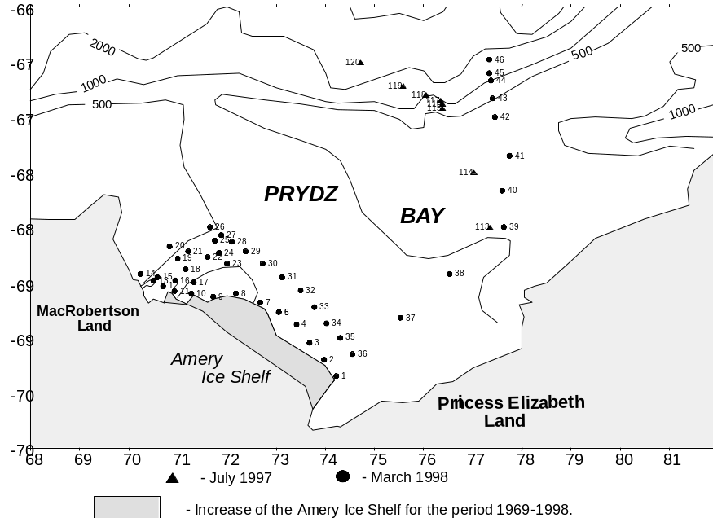
Figure 4.8-24 “Akademik Fedorov” sections. July 1997 and March 1998.
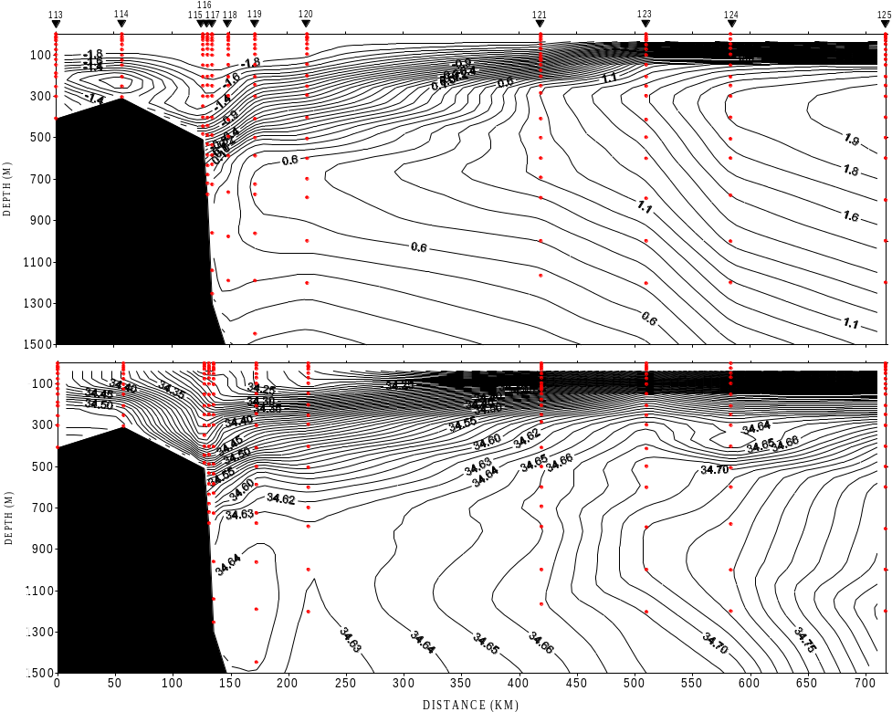
Figure 4.8-25 Potential temperature and salinity on the section of “Akademik Fedorov” (July 1997).
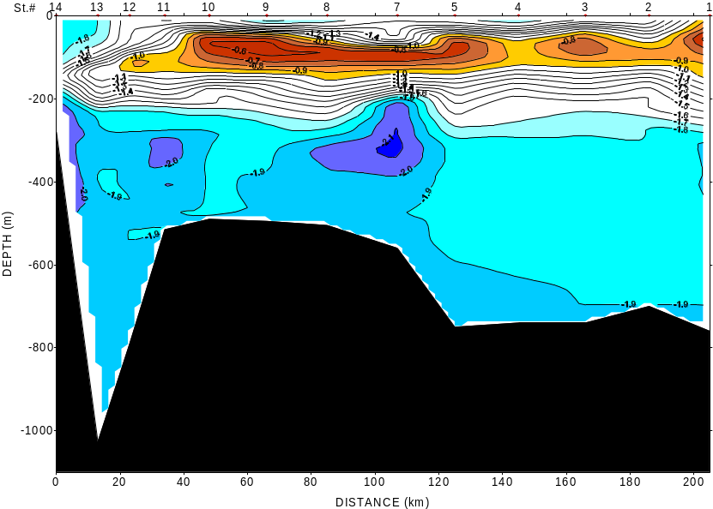
Figure 4.8-26 Potential temperature on the section along the edge of the Amery Ice Shelf (“Akademik Fedorov”, March 1998).
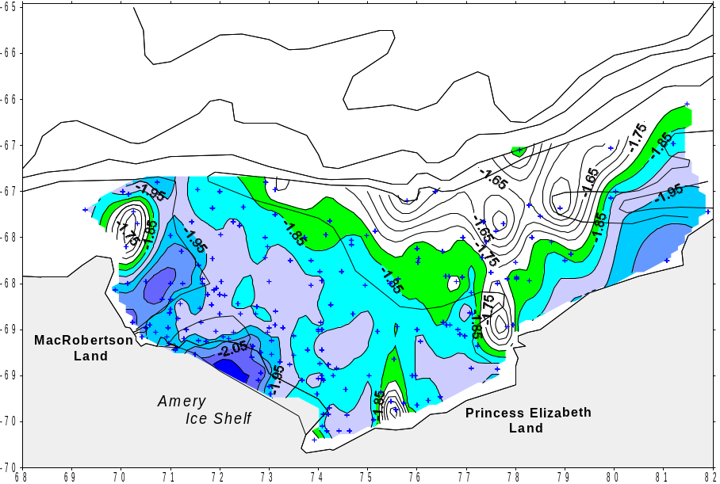
Figure 4.8-27 Potential temperature of the Shelf Water and Ice Shelf Water (1997 and 1998 data and historical data. 204 stations in total).
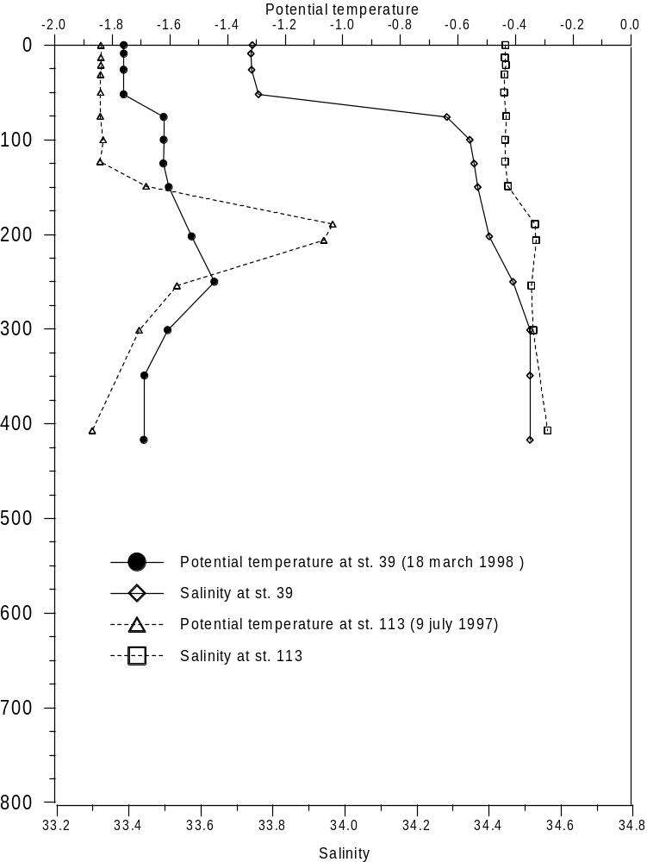
Figure 4.8-28 Potential temperature and salinity profiles at stations 113 (July 1997) and 39 (March 1998) in the shelf region of the Prydz Bay.

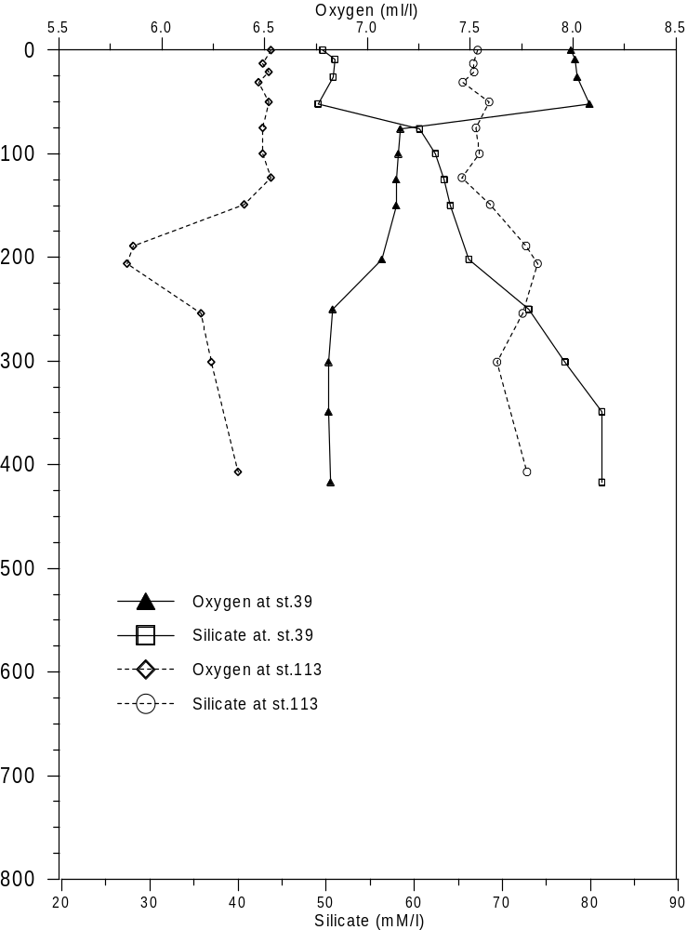
Figure 4.8-29 Oxygen and silicate profiles at stations 113 (July 1997) and 39 (March 1998) in the shelf region of the Prydz Bay.

Spain
M. Garcia

Repeated sampling on SR1b
The Burdwood Bank-Elephant Island section across the Scotia Sea (known as SR1b in WOCE terminology) was sampled by BIO Hesperides in February 1995, February 1996, February 1998 and January 1999. The comparison of property distributions obtained in each occupation and ancillary ADCP data and AVHRR imagery has allowed a description of factors producing changes in the hydrographic structure and the ACC transport at different time scales. Most of the conclusions support earlier findings and statements made by other authors. On the other hand, eddy generation east of the Shackelton Fracture Zone is believed to be a major cause for observed mesoscale variability in the southern Antarctic Zone band of SR1b. A paper dealing with the Hesperides 1995, 1996 and 1998 observations has been submitted to JGR Oceans recently.

DHARMA
A multidisciplinary study entitled DHARMA (Diversity, Heterotrophy, Autotrophy and Relationships among Microorganisms in Antarctica) was carried out on board BIO Hesperides between 28th December, 1998 and 10th January, 1999. The main aims of the study were to produce new data on the abundance, the diversity and the activity of microbial plankton across the Scotia Sea and in the adjacent NW Weddell Sea, Bransfield Strait and Gerlache Strait sectors.
Figure 4.9-30 shows the station map of the DHARMA cruise. 106 CTD/Rosette profiles were carried out during the cruise. A volume of 25,000 l of seawater was obtained and sampled for different physical, chemical and biological variables.The ADCP system was out of service during the cruise. DHARMA is regarded as the most comprehensice microbiological surveying ever achieved in Antarctic seas.
During the DHARMA cruise, the AWI206-5, AWI215-4 and MIR-II moorings deployed by FS Polarstern in May 1998 were recovered. These moorings contained German and Spanish instruments and were deployed in the framework of the DOVETAIL project. A fourth German/Spanish mooring, AWI207-5, could not be recovered due to adverse sea ice conditions at the mooring site. In addition, a Korean current meter mooring which was deployed by R/V Polar Duke near Joinville Island in December 1997 was recovered at the request of the Korean Ocean Research and Development Institue.
The DHARMA scientific crew was integrated by researchers and technicians from the Institut de Ciencies del Mar de Barcelona (leading institution), the Universitat Politecnica de Catalunya, the Instituto de Investigaciones Mariñas de Vigo, the Universidad del Pais Vasco, the Universidad Miguel Hernandez de Alicante and the Instituto Mediterraneo de Estudios Avanzados.

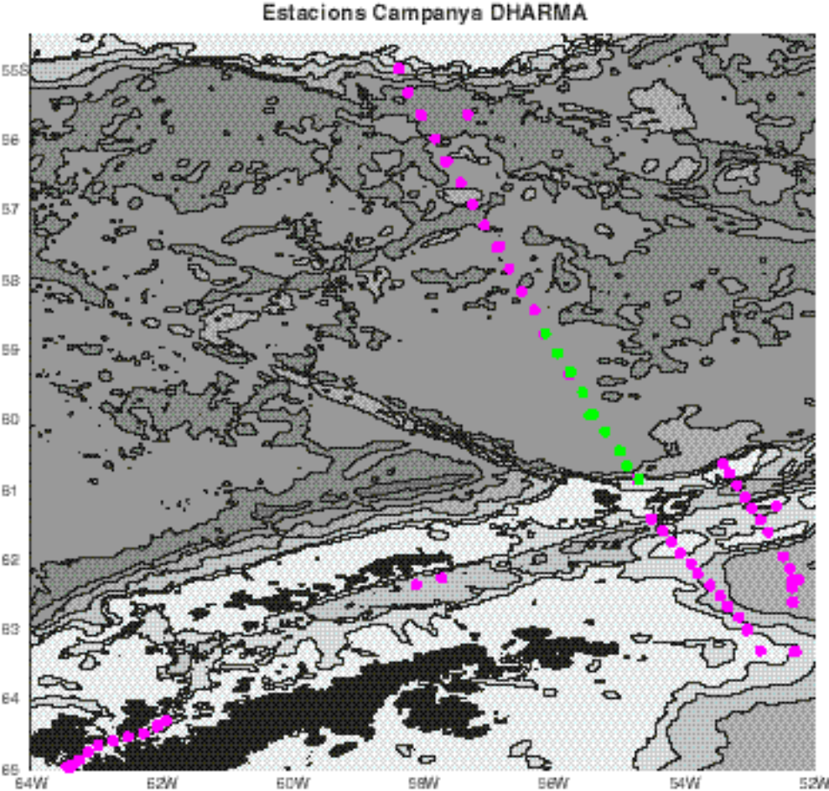
Figure 4.9-30 DHARMA cruise. Station map.

U.K.
K. Heywood
The past U.K. activities are presented as a contribution to the DOVETAIL project and as a contribution to FRISP in the German presentation. Future plans are displayed here:
UK Thematic Program : Autosub Under Ice
K. Heywood
School of Environmental Sciences
University of East Anglia
Norwich
NR4 7TJ
There has been a recent Announcement of Opportunity from the UK Natural Environment Research Council to conduct research under ice using the autonomous submersible Autosub. Outline bids will be requested in spring 2000 so we do not yet know what science will be included. However it is intended that there will be 3 field seasons, two in the Antarctic and one in the Arctic. The focus of the program is likely to be on taking Autosub under glacial ice shelves in the southern Weddell Sea and Antarctic Peninsula, but work under sea ice is also included. There is emphasis on physical processes on and near the continental shelves of Antarctica, relevant to climate.
Funding is likely to start in spring 2001 with the first Antarctic field season being 2001-2002.
Cooperation with the iAnZone projects will obviously be beneficial and encouraged.
Further information is available on the website
[URL 5] http://www.nerc.ac.uk/ms/Autosub/
which will be updated as projects are funded by the program.

USA

- The Southern Ocean component of CORC (Consortium for the Oceans' Role in Climate)
B Huber
M. Visbeck and A. L. Gordon, Physical Oceanograpy Principal Investigators; P. Schlosser and W. Smethie, Tracer PIs, Lamont-Doherty Earth Observatory
CORC Objectives
One of the objectives of the Southern Ocean component of CORC is to improve the understanding of the effect of global climate on regional and local scales. In an effort to investigate changes in the production and characteristics of Weddell Deep Water (WDW), Weddell Sea Deep Water (WSDW), and Weddell Sea Bottom Water (WSBW), a time series of temperature, salinity, and velocity data is being obtained near the outflow of these waters from the Weddell Sea (Figure 4.11-31). Ultimately, a ten-year time series in the northwest Weddell Sea is planned in an area which should encompass the Weddell Sea flow of these waters. The first cruise in this series was carried out from the RVIB Lawrence M Gould in April 1999. The specific objectives of this CORC cruise were to deploy a set of moorings to monitor temperature, salinity, and currents in the lower water column and to obtain repeat CTD profiles and water samples along a transect in the northwest Weddell Sea.
1999 Cruise
The observational program included: CTD/OXY and lowered ADCP sensors; water samples for salinity, oxygen, CFC, and Tritium/Helium; and three moorings (Table 4.11-3 and Table 4.11-4; Figure 4.11-32.). The CTD transect and mooring locations lie roughly along a section occupied during the US Dovetail program of 1997. Several of the CTD stations are repeat occupations of US Dovetail CTD stations and it is hoped to continue re-occupation of these sites on each future CORC cruise.
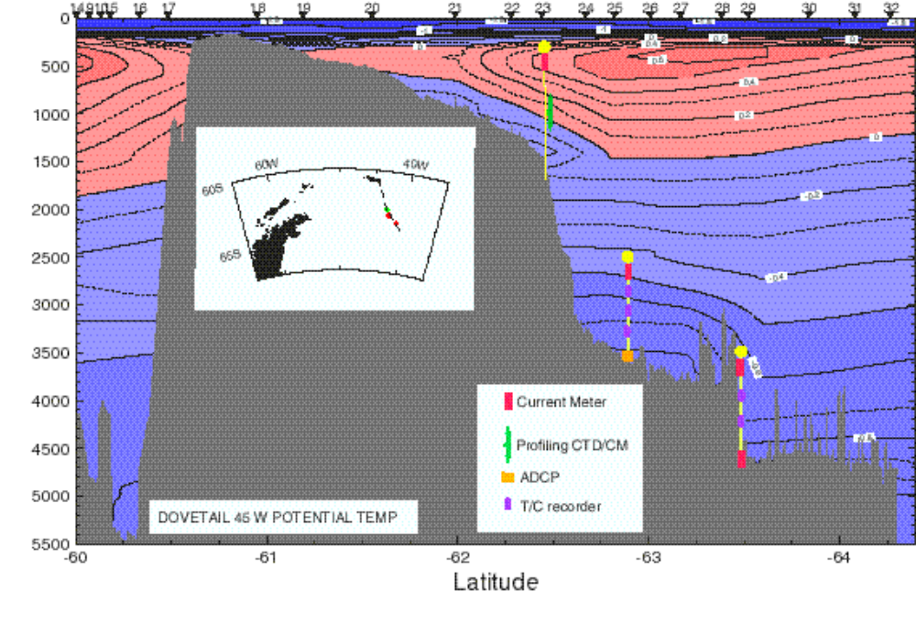
Figure 4.11-31 CORC Mooring array superimposed on potential temperature section obtained during the US Dovetail Cruise in 1992.

Table 4.11-3 CORC 1999 CTD Station Positions
CTD | Date | Time(Z) | Latitude | Longitude | Bottom Depth
1 | 3/27/99 | 22:12 | 62º 11.405’ S | 64º 45.111’ W | 440
2 | 3/30/99 | 16:38 | 64º 43.478’ S | 57º 19.590’ W | 417
3 | 3/31/99 | 17:24 | 63º 22.725’ S | 48º 56.467’ W | 1239
4 | 4/1/99 | 19:53 | 64º 15.931’ S | 39º 59.120’ W | 4721
5 | 4/1/99 | 21:20 | 64º 15.762’ S | 39º 55.074’ W | 4766
6 | 4/2/99 | 03:14 | 64º 16.053’ S | 39º 58.957’ W | 4766
7 | 4/2/99 | 09:48 | 63º 49.962’ S | 41º 00.042’ W | 4593
8 | 4/2/99 | 19:05 | 63º 31.069’ S | 41º 44.107’ W | 4605
9 | 4/3/99 | 00:34 | 63º 31.217’ S | 41º44.511’ W | 4568
10 | 4/3/99 | 05:14 | 63º 22.786’ S | 42º 1.497’ W | 3504
11 | 4/3/99 | 11:26 | 63º 2.971’ S | 42º 24.941’ W | 3709
12 | 4/3/99 | 21:35 | 62º 37.575’ S | 43º 10.387’ W | 3206
13 | 4/4/99 | 02:57 | 62º 54.986’ S | 42º 43.877’ W | 3585
14 | 4/4/99 | 09:04 | 62º 41.013’ S | 43º 13.018’ W | 3270
15 | 4/4/99 | 13:55 | 62º 30.042’ S | 43º 17.780’ W | 1942
16 | 4/4/99 | 21:05 | 62º 26.549’ S | 43º 19.751’ W | 1464
17 | 4/5/99 | 00:30 | 62º 16.761’ S | 43º 38.469’ W | 1176
18 | 4/5/99 | 04:17 | 61º 59.065’ S | 43º 54.919’ W | 910
19 | 4/5/99 | 08:47 | 61º 33.015’ S | 43º 58.581’ W | 518
20 | 4/5/99 | 12:43 | 61º 10.948’ S | 44º 2.103’ W | 376

Table 4.11-4 CORC Mooring Positions (deployed April 1999)
ID | Latitude | Longitude | Depth | Deploy Date
1 | 62º 30.292’ S | 43º 17.717’ W | 1986 | 4/2/99
2 | 62º 37.054’ S | 43º 13.092’ W | 3140 | 4/3/99
3 | 63º 31.400’ S | 41º 47.036’ W | 4560 | 4/4/99

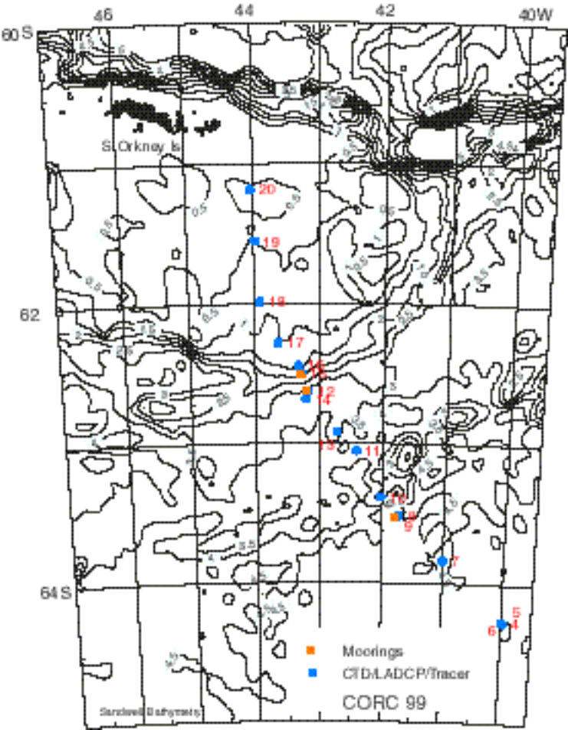
Figure 4.11-32 CORC 1999 Station and Mooring Positions
Preliminary Findings and Future Plans
Data from the first mooring deployment has not yet been recovered. A recovery cruise will take place 28 March - 21 April 2000 on L M Gould, during which the moorings will be recovered and redeployed, and CTD/LADCP stations will be occupied along the same track. Time and weather permitting, the track will be extended to the southeast, to penetrate further into the Weddell Gyre.
Preliminary CTD data are shown as a section of potential temperature ( Figure 4.11-33) and θ/S ( Figure 4.11-34). It is noted that the temperature of the θ_{max} measured during CORC-99 was slightly cooler than that measured along the same section during the 1997 US Dovetail cruise.

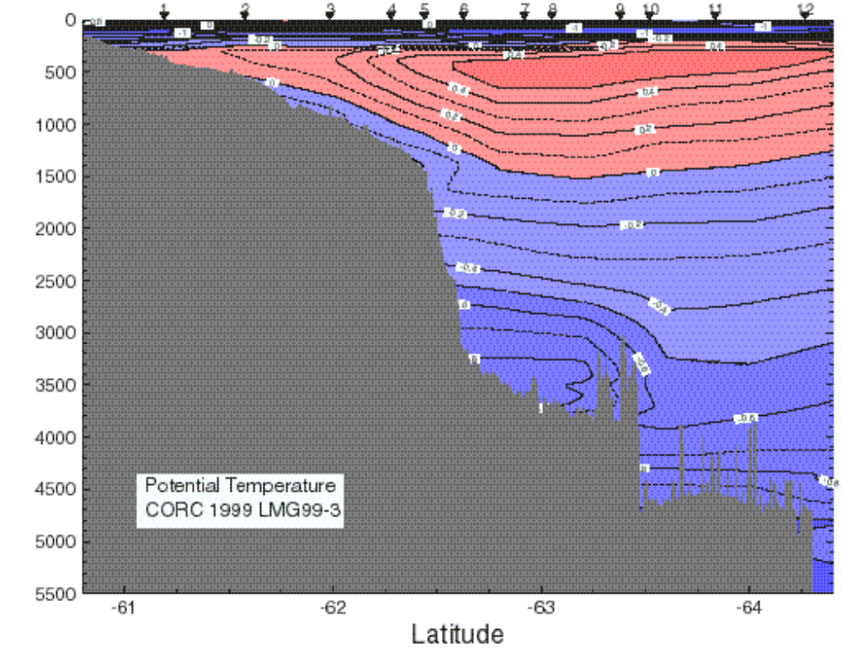
Figure 4.11-33: Potential Temperature section along the CORC-99 cruise track, coincident with the 1997 US-Dovetail cruise track along 48°W (see Figure 4.11-31).

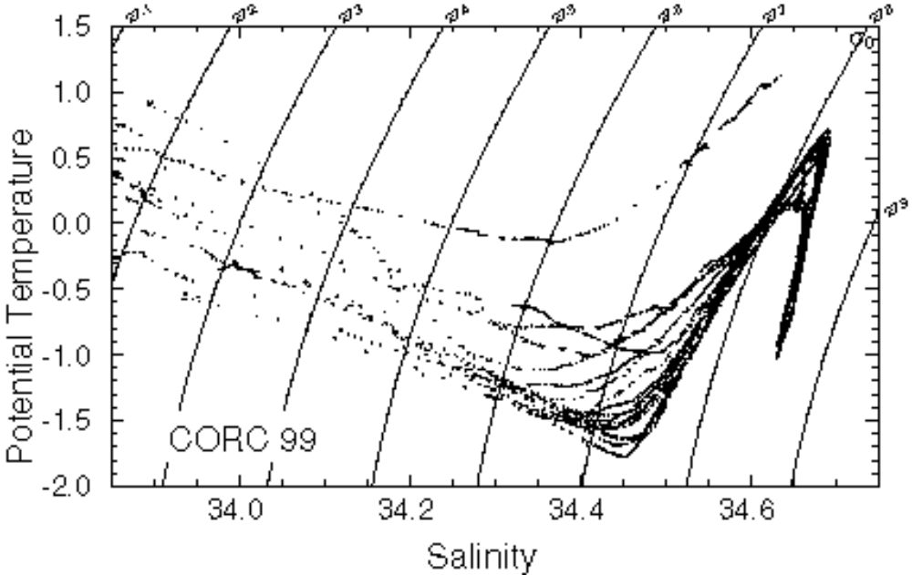
Figure 4.11-34: Potential Temperature-Salinity plot from CORC -99 CTD stations (preliminary data)

Analysis of Southern Ocean WOCE data
Alex Orsi
A basic description of the large-scale circulation of the Pacific sector of the Southern Ocean was presented, focusing on mean circulation systems with specific new ingredients in the ACC frontal structure and internal cells in the Ross Sea environs. Property distributions were used to infer the most direct inflows of ACC waters toward the Antarctic continental slope. Characterization of the Antarctic Slope Front was possible by the two slope/shelf segments of the WOCE Pacific S4 line. Main water mass structure was detailed to distinguish between inflowing and outflowing water masses across that line. As a result, a production rate estimate for new Ross Sea Bottom Water was obtained. Bottom and isopycnal distributions reveal that most of these Ross Sea waters are actually exported to the west and fill the adjacent Australian Antarctic Basin.

Status of iAnZone Exp #4 (Convection) planning,

Introduction
The Objective of Convection are: To obtain a quantitative estimate of the effect of Antarctic zone water mass modification on the global thermohaline circulation and to establish the basis of an observational system which allows to improve and validate the representation of Southern Ocean convection in large scale models.
To meet the objectives three components are planned which refer to the major processes involved in water mass transformation around Antarctica. The large range of involved time and space scales require different approaches for the different processes and long term observation period to assess the low period variability.

Continental Margin Convection:
This component is directed at the formation of the parent shelf water masses contributing to deep reaching convection, mixing within the continental margin frontal structures, and the plume convection feeding the deep and bottom water ventilation. This component includes:
a- shelf waters coupling to atmospheric and sea ice (and coastal polynya) forcing as well as shelf water interaction with the ice shelves, ice bergs and ice tongues;
b- the variety mixing processes, including coastal waves and tidal action, and equation of state subtleties and their associations with bottom topography and slope circulation and fronts that enable deep reaching convection; and
c- the dynamics and entertainment characteristics of the convective plumes characteristic of many continental slopes of Antarctica.
Workshops were held 8-9 February and 27-29 September 1999 to coordinate plans for the next phase of field work to investigate Continental Margin processes. Workshop reports and updates can be obtained from the Project 4 page on the iAnZone website:
[URL 6] http://www.ldeo.columbia.edu/physocean/ianzone/project_4/index.html

Open Ocean Convection

Contribution to iAnzone#4 Convection in the Weddell Sea
Eberhard Fahrbach
Investigations of ocean convection in the Weddell Sea are planned in the framework of iAnzone#4. There will be two approaches: the large scale and long term effects which describe the preconditioning and the result of convection are studied in the framework of a multiyear mooring and CTD programme which is presented in this part of the report. Small scale and shorter period processes are planned to be investigated in a programme under US leadership presented by Miles McPhee.
Large scale processes and long-term variations of convection in the Weddell Sea
The Antarctic ocean contributes through atmosphere-ice-ocean interaction processes to the variability of the climate system. The ice cover has a strong control on the albedo and on the ocean-atmosphere heat exchange. At the same time the advective heat supply from the ocean controls the ice cover. Atmosphere-ice-ocean interaction leads to water mass conversion which occurs in open ocean and on the shelves. Whereas the shelf processes affect a reservoir limited through the shallow water depth and the cross-frontal transports at the shelf edges, open ocean processes can affect deeper layers directly if the stability of the water column is weak.
In the Weddell Sea, Circumpolar Deep Water enters from the north and circulates in intermediate layers within the large scale cyclonic gyre. By upwelling and entrainment heat and salt is transported from that water mass into the surface layers. The vertical transport of heat and salt counteracts to the heat loss and the fresh water gain at the sea surface. The delicate balance controls the stability of the water column. The vertical transports can be significantly affected by vertical flow and enhanced mixing in the vicinity of topographical features like Maud Rise.
Under conditions of a relatively stable water column shallow open ocean convection represents a preconditioning for the shelf processes through heat extraction and salt redistribution of the source waters which are involved in frontal processes over the continental slope. In the case of relatively unstable conditions, open ocean convection can reach deeper layers and contribute directly to the deep water formation. Unstable conditions enhance the heat transport from the ocean towards the surface to an extent that large areas of the winter sea ice are melted and a open ocean polynya is formed which then allows large heat losses of the ocean increasing the water mass conversion.
Recent observations indicate that the water mass properties of the Warm Deep Water are subject to significant variations. It is most likely that the variations are due to changes in the inflow from the north, however changes in the ice-ocean-atmosphere interaction in the Weddell Sea might be of importance as well. At present it is not possible to conclude, if the remotely induced changes could lead to a transition from shallow to deep ocean convection, or if the observed variations are fluctuations around "normal" conditions.
The objectives of the project are:
- to determine the variation in water mass properties in the convective area north and west of Maud Rise
- to determine the variability in characteristics and amount of the inflowing Circumpolar Deep Water
- to determine the effect of variations in the elements of the fresh water budget as sea ice transport and iceberg melt on the stability of the water column
- to estimate the effect of topographic features like Maud Rise to intensify vertical transports
- to determine the potential of remote and local effects to induce variability in the atmosphere-ice-ocean interaction
- to estimate the contribution of open ocean convection in the Antarctic zone to the ventilation of the global ocean
- to estimate the potential of abrupt changes
The observational program contains the following components:
The observations should cover the transition from a "normal" condition of shallow convection to an - at present exceptional - situation of deep convection. Consequently the observations have to cover at least a decadal time period. A moored observing system is maintained since 1996. Current meter moorings were exchanged in 1998 and 1999 ( ). A redeployment is planned for the austral summer 2000/2001. The moorings are equipped with current meters, temperature and conductivity sensors to measure the vertical distribution of the currents and water mass properties to determine the stability of the water column. In the area of the Weddell Front three sea level recorders were deployed in 1999 to detect variations in the location of the front as an indicator of changes of the inflow of Circumpolar Deep water into the Weddell Sea as a contribution to WCRP CLIVAR project. ( Figure 5.3-36). The inflow will be tracked by 10 APEX floats which were deployed in the northern Weddell gyre and southern Antarctic Circumpolar Current too. A redeployment is planned for 2000. Upward looking Sonars in 150 m depth are installed on six moorings in the framework of the WCRP Antarctic Sea-Ice Thickness Project (ANSITP) to determine the sea ice transports (see the following website).
[URL 7] http://www.awi-bremerhaven.de/Research/ansitp/index.html
Ten icebergs are marked by satellite transmitters in 1999 to determine their tracks from the Antarctic coast into the melting area. Moored systems are not able to measure in the near surface layers and can not supply a sufficient horizontal resolution. Therefore shipborne measurements are required. In 1996, 1998 and 1999 hydrographic surveys were carried out along the Greenwich Meridian with a CTD-probe (Conductivity/Temperature/Depth) combined with a rosette water sampler ( Figure 5.3-36). From the water samples, measurements of the following tracers are carried out: CFCs (Freon-11 and Freon-12, Freon-113, CCl4), tritium, 3He, He, and Ne. A repeat of this transect is planned for 2000/2001.
Norway plans to deploy a mooring on top of Maud Rise with current meters and with an ULS. By acoustic measurements the sea state should be monitored
The observations will be accompanied by a hierarchy of modeling efforts. High resolution models have to be used to investigate the effect of variations in the atmospheric forcing and the inflow from the north. The effect of the shape of the bottom topography, in particular structures like Maud Rise must be investigated in an ice-ocean interaction model with sufficient horizontal resolution.
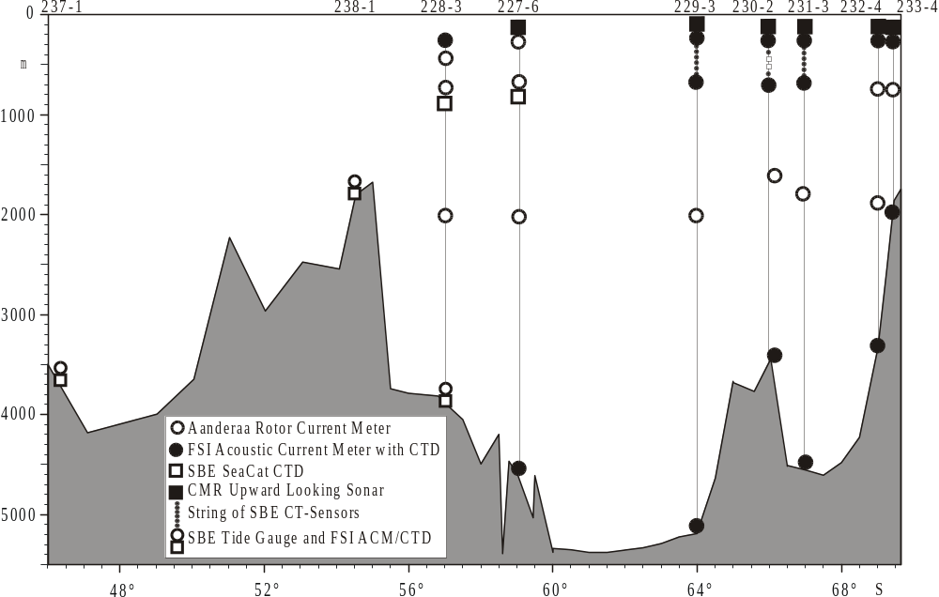
Figure 5.3-35: Schematical representation of the moorings deployed in January and March 1999 along the Greenwich Meridian.
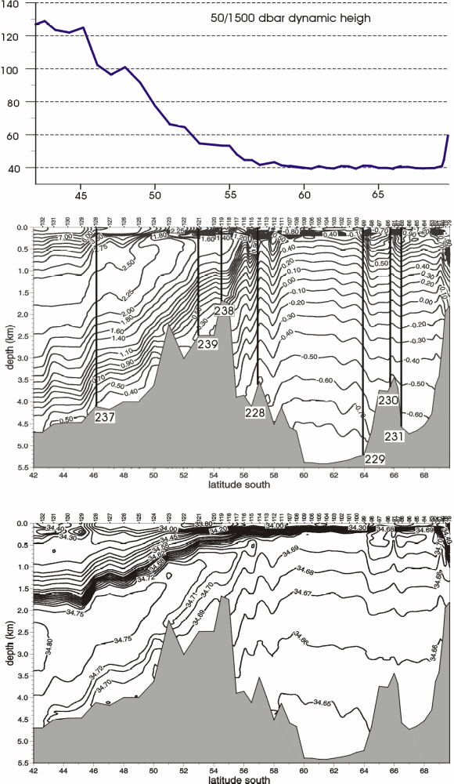
Figure 5.3-36: Geopotential height anomaly at 50 db relative to 1500 db (top), potential temperature (centre) and salinity (bottom) on a section from 42°S to 69°38'S between South Africa and the Antarctic continent measured from R.V."Polarstern" during ANT XV/4 in May 1998. The sea level recorders (228, 237, 238, 239) and the moorings west of Maud Rise (229, 230, 231) are indicated on the transect.

Small scale processes in Weddell Sea convection: Thermobaric instability over Maud Rise
Miles McPhee
Passive microwave satellite imagery during the late 1970s revealed a large expanse of open water (or low concentration sea ice) that persisted for several seasons well within the confines of the annual sea ice limits of the Weddell Sea. Gordon (1991) interpreted the feature (the Weddell Polynya) as manifestation of deep convection far removed from the continental margin, indicating a mode of air-sea-ice interaction different from the present, one in which ice formation is relatively infrequent and ephemeral, even in winter. The water column in the central and eastern Weddell is often only marginally stable, and there are many regions where a combination of modest ice growth and reasonable heat loss to the atmosphere could drive the system to convective instability, i.e., where destabilizing surface buoyancy flux would mix the water column to great depth, venting large amounts of oceanic heat (Martinson and Iannuzzi, 1998).
The problem with invoking destabilizing surface buoyancy flux to maintain persistent convection is that, in most cases, salt rejection from ice growth is required to densify the mixed layer enough for convection. As soon as the mixed layer becomes unstable relative to its underlying pycnocline, significant heat is mixed up into the mixed layer from below. This melts ice, and the ensuing freshwater influx rapidly stabilizes the system, reducing or eliminating the mixing source. ANZFLUX results demonstrated that energetic storms common to the region do in fact induce significant mixing and upward heat flux, but also illustrated the see-saw nature of the freeze-melt cycle (McPhee et al., 1996; 1999). During the ANZFLUX drift over Maud Rise in August, 1994, our perception was that the upper ocean would remain stably stratified because of the presence of a thin, but extensive ice cover. Nevertheless, within one to two weeks after our departure from the Maud Rise region, satellite imagery indicated a widespread area of opening near the site of our second ANZFLUX drift experiment (Drinkwater, 1997).
Until recently, most deep ocean convection scenarios have relied on strong ice divergence to mechanically remove the stabilizing buoyancy source represented by melt- ing ice. Work by Garwood (1991), Garwood et al. (1994), and recent papers by Akitomo (1999a;b) show a different way to resolve the conundrum. The thermal expansion factor for seawater depends on pressure; i.e., the equation of state varies nonlinearly with depth. Consider near freezing water of a given temperature and salinity that is stable near the sur- face with respect to an underlying layer of warmer, saltier water. Because the thermal expansion factor increases with pressure, if the first water mass is displaced downward its stability will decrease relative to the second type. Under certain conditions, this phenomenon (thermobaricity) can lead to an instability with overturn and mixing. Akitomo (1999a) demonstrated that much of the Weddell Sea is potentially unstable in a thermobaric sense. The crucial point is that once triggered, thermobaric overturn no longer relies on being driven by surface buoyancy and momentum flux, but instead derives its mixing energy from the potential energy of the water column. Akitomo shows by scaling arguments and numerical modeling that thermobaric buoyancy flux can overcome a fairly strong stabilizing tendency from surface melting. Once the ice has melted, surface cooling alone will sustain deep convection by supplying destabilizing surface buoyancy flux.
Temperature and salinity profiles from the Maud Rise drift of ANZFLUX were analyzed for thermobaricity using a criterion that takes into account the combined sensible and latent heat loss required to drive a given profile to thermobaric instability, based on the difference between actual density (including the pressure contribution) and the density of an equivalent water column with mixed layer temperature and salinity (McPhee, 2000). The thermobaric barrier is mapped for the Maud Rise drift in Figure 5.3-37. From this analysis, 38 yo-yo CTD stations had values of 100 MJ m⁻² or less for H_{tot}, and were considered susceptible to thermobaric instability. Each of these profiles was used to initialize a one- dimensional, upper ocean/ice model, forced by stress and ice conductive heat flux inferred from data gathered by a buoy left at the site of the first ANZFLUX drift (McPhee et al., 1999). In the model, 27 profiles, about a quarter of the total measured with in the ANZFLUX yo-yo CTD program in the Maud Rise region, became thermobarically unstable by the end of August, 1994. An example of modeled ice/ocean response is shown in Figure 5.3-38, taken from McPhee (2000).
A common feature of the profiles that exhibited thermobaric susceptibility was (a) the presence of step-like structures in the pycnocline underlying the surface mixed layer, and (b) location between the 2.5 and 3 km isobaths over the flanks of the Maud Rise sea- mount. Padman et al. (in press, J. Geophys. Res.) suggest that the sub-mixed-layer steps result from cabbeling instability, driven by the advection of salt-enriched surface water over filaments of Warm Deep Water uplifted along the flanks of Maud Rise. Thus the combination of various nonlinearities in the equation of state for seawater may be a requirement for sustained deep convection in the Maud Rise region.
Given significant interest in deep ocean convection at high latitudes, we recommend a focused project with objectives:
Determining the water characteristics and processes that precondition the water column over Maud Rise for thermobaric instability.
Obtaining quantitative estimates of the buoyancy flux associated with conversion of water column potential energy by thermobaricity.
Determining the processes that would shut down deep convection once the ice cover had been mostly eliminated by thermobaric overturn (i.e., after the major source of stabilizing buoyancy flux is removed).
To accomplish these objectives we envision a sustained modeling effort using various approaches, including directly simulating thermobaricity via large eddy simulation modeling; and by developing reasonable parameterizations for lower resolution models.
We also recommend a late winter cruise into the Maud Rise region, with the specific purpose of searching for conditions conducive to thermobaric instability. Measurements would be mostly ship based and would include:
- High frequency (relatively shallow) CTD profiles
- Microstructure turbulence measurements
- Direct flux and energy and scalar spectra measurements, both near the surface and near the base of the mixed layer
- Doppler sonar current measurements at multiple vertical resolution (frequencies)
- Real time active and passive satellite microwave support.
- Surface meteorological conditions
- Ice heat and mass monitoring
Our hope would be to encounter active thermobaric mixing, and to measure ocean and ice fluxes associated with it.
References
Akitomo, K. 1999a: Open-ocean deep convection due to thermobaricity. 1. Scaling argument. J. Geophys. Res., 104 (C3), 5225-5234.
Akitomo, K. 1999b: Open-ocean deep convection due to thermobaricity. 2. Numerical experiments, J. Geophys. Res., 104 (C3), 5235-5249.
Drinkwater, M. R., 1997: Satellite microwave radar observations of climate-related sea-ice anomalies, Bull. Am. Met. Soc., Proc. Workshop on Polar Processes in Global Climate, 13-15 Nov., 1996, 115-118.
Garwood, R. W., Jr., 1991: Enhancements to deep turbulent entrainment, in Deep Convection and Deep Water Formation in the Oceans, eds. P.C. Chu and J. C. Gascard, 197-213, Elsevier, New York.
Garwood, R. W., Jr., S. M. Isakari, and P. C. Gallacher, 1994: Thermobaric convection, in The Polar Oceans and Their Role in Shaping the Global Environment, Geophys. Monogr. Ser., 85, eds. O. M. Johannessen, R. D. Muench, and J. E. Overland, 199-209, AGU, Washington, D.C.
Gordon, A.L., 1991. Two stable modes of Southern Ocean winter stratification, In: Deep Convection and Deep Water Formation in the Oceans, Eds. P-C Chu and J-C Gascard, Elsevier Oceanography Series, 57, 17-35, Elsevier, Amsterdam.
Huber, B., P. Schlosser, and D. G. Martinson, 1995: Thermohaline structure and tracer studies during ANZFLUX, Antarctic J. U. S., 30, 129-130.
Martinson, D.G., and R. A. Iannuzzi, 1998: Antarctic ocean-ice interaction: Implications from ocean bulk property distributions in the Weddell Gyre, in Antarctic Sea Ice: Physical Processes, Interactions and Variability, Antarctic Research Series, 74, 243- 271.
McPhee, M. G., 2000: Marginal thermobaric stability in the ice-covered upper ocean over Maud Rise. In press, J. Phys. Oceanogr.
McPhee M. G., S. F. Ackley, P. Guest, B. A. Huber, D. G. Martinson, J. H. Morison, R. D. Muench, L. Padman, and T. P. Stanton, 1996: The Antarctic Zone Flux Experiment, Bull. Am. Met. Soc., 77, 1221-1232.
McPhee, M.G., C. Kottmeier, and J. Morison, 1999: Ocean heat flux in the central Weddell Sea during winter, J. Phys. Oceanogr., 29, 1166-1179.
Padman, L., R. Muench, and E. Fahrbach, 1999: Cabbeling catastrophes, in press, J. Geophys. Res.
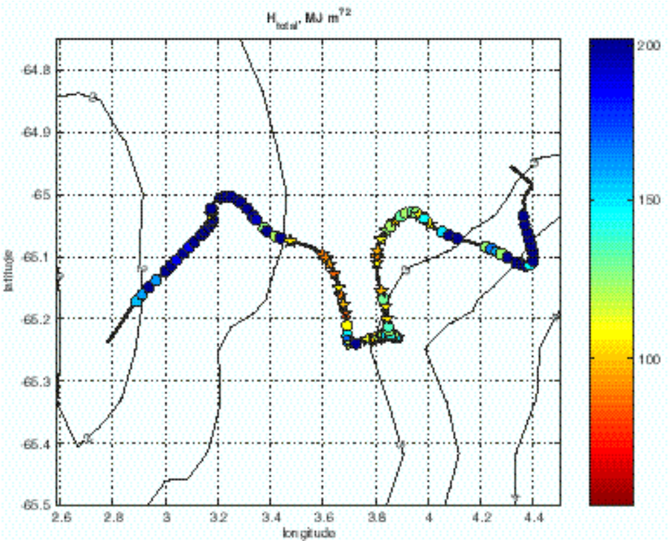
Figure 5.3-37. Thermobaric barrier (total required heat extraction to drive the observed profile to ther- mobaric instability) from the ANZFLUX yo-yo CTD program during the Maud Rise drift in early August, 1994. Contours show depth in km. Pentagrams mark profiles for which a coupled, one-dimen- sional ice/ocean model reached thermobaric instability by the end of August, driven by stress and con- ductive heat flux inferred from drifting buoy measurements. From McPhee (2000).

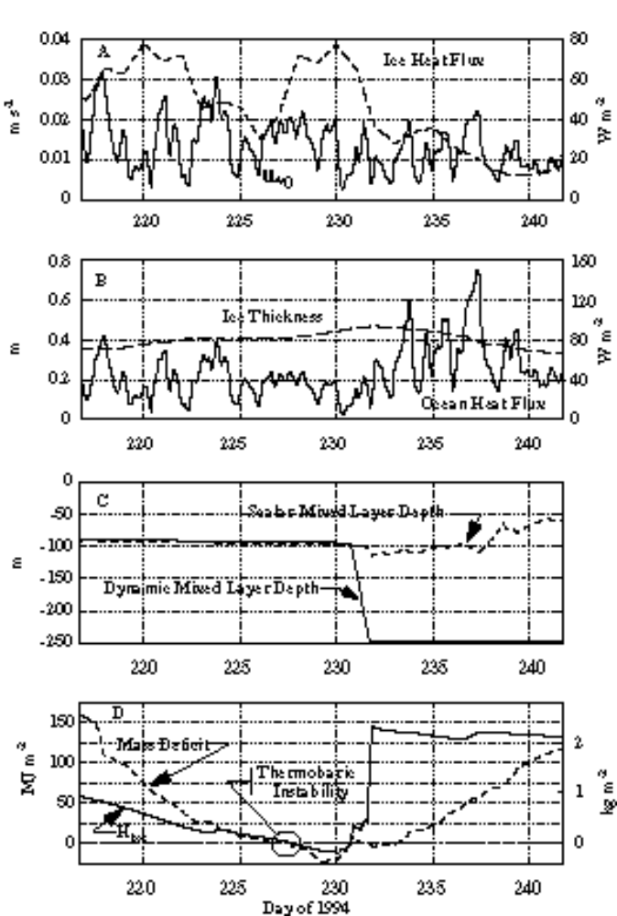
Figure 5.3-38Results from one-dimensional model- ing of upper ocean evolu- tion, initialized with ANZFLUX yo-yo station YU075. A. Friction ve- locity at the ice/ocean boundary (solid), and conductive heat flux in- ferred from the buoy ice temperature gradient (dashed). B. Modeled ice thickness and ocean- to-ice heat flux. C. Modeled mixed layer depth, based on the den- sity gradient (solid) and on the difference be- tween salinity and near surface salinity (dashed). Type I con- vection into the lower step layer begins on day 231. D. The mass deficit (dashed) and ther- mobaric barrier (solid). The circled time (day 227, 15 Aug 94) indi- cates when modeled conditions would insti- gate Type II (ther- mobaric) convection.

Monitoring convection products in Weddell and Ross seas
The Southern Ocean component of CORC has deployed a set of moorings in the outflow of the Weddell Gyre to obtain long-term observations of deep and bottom water properties exiting the Weddell Sea. along its western margin. The moorings and a repeat CTD section are positioned to enable monitoring of convection products from the western Weddell and their influence on deep and bottom water variability. A project description and preliminary results are presented in Section 4.11.1 .

Discussion
The lively discussion covered some points which were deferred until a later workshop, which was subsequently held 27-29 September 1999 at Lamont-Doherty Earth Observatory. See
[URL 8] http://www.ldeo.columbia.edu/physocean/ianzone/project_4/index.html
for a report of the workshop and for future updates.
Intensive discussions occurred about the correct use of the term convection. Whereas some participants held that slope processes should not be included under the term convection, it was argued that the use of the term convection is widely accepted in literature for both processes. A more inclusive term was not presented for discussion. Therefore no decision to change the name of the project was taken.
Other points of critique by Steve Rintoul were brought forward to be addressed in the slope convection workshop.
- Is the Ross Sea an appropriate place for a slope convection field experiment as it is known not to be a strong source of bottom water?
- the slope front is not the valve for the bottom water formation, because it is too small to control the large volume which is necessary to ventilate the world ocean.
- bottom topography might have a stronger control than the front, in particular the flow through canyons.

Coordination with other large Programs

ASPeCt
I. Allison
ASPeCt Report at GLOCHANT Group of Specialists Meeting, April 1999, UNH, Durham NH

Science and Implementation Plan
Antarctic Sea Ice Processes and Climate, ASPeCt, had its second meeting of the Science Steering Group in Monterey California on 4-5 March 1999. The principal activity at the meeting was to finalize the Science and Implementation Plan which had been outlined at the first meeting of the SSG and principally completed by correspondence since then. The final remaining sections were completed or initiated at the meeting, and made available by 1 April. We adhered to a schedule set out where a completed version of the Science and Implementation Plan was to be available for the Glochant meeting in April. At the SSG meeting we outlined our publication plans. The full plan was to be published and available in the ASPeCt section of the Glochant web site:
[URL 9] http://www.antcrc.utas.edu.au/scar/
and a short brochure would be printed that would summarize the main features of the plan and be widely distributed in hard copy form. ASPeCt would also prepare an article for publication in EOS, to be submitted in July 1999. The Glochant GOS concurred with this plan. Since the Glochant meeting, final editing of the Plan was completed and the full plan was published and available on the web page by 10 May 1999. A draft version of the brochure text was completed by 1 May (to be used by Julian Priddle at the IGBP meetings), and was being edited and layout begun for publication by 1 June 1999.

Data Rescue Project on Antarctic Pack Ice Snow and Ice Thickness Distributions
ASPeCt had mounted a data rescue project to obtain available records from vessels that had transited the Antarctic pack ice from 1980-1997. The purpose is to provide a statistical characterization of the ice thickness distribution in Antarctic sea ice for this period. The records are available however, in a variety of formats, so a major effort has been to reformat the records in the 'standard' format that has been adopted for use in the pack ice zone. This new format, developed by Ian Allison and Tony Worby of the Antarctic CRC will allow presentation of the data in digital form and will give a statistical characterization or "climatology" of snow and ice thicknesses (and other characteristics) of the pack ice zone for that period. As of April 1999, 42 voyages (~12,000 observations) were either available or had been reformatted into the standard format. This effort was partially funded by SCAR, and contributions were made to the effort from Russia, Australia, USA and Germany. An additional 34 voyages are currently being processed, with an anticipated completion of the data reformatting by 1 Jan 2000.
Several avenues will be pursued for dissemination of the data set after Jan 2000. A limited access ftp site will be set up for interacting members of the modelling community as a testbed for model validation and improvement shortly after all the data sets are available. In early 2000, atlas summaries, contour maps and other products from the data will be prepared and published in journals and on the web site, after appropriate review by the SSG and other interested members of the community. A project to publish the data on a CD-Rom along with ice maps and other satellite-derived data will also be initiated later in 1999. This effort will be a joint effort between ASPeCt and the National Ice Center in Suitland MD.

Ice Observation Methods CD-Rom
Tony Worby, ASPeCt Project Scientist, has completed a CD-Rom to be used as a guide for conducting sea ice observations from vessels operating in Antarctic pack ice for ASPeCt. The ASPeCt budget under GLOCHANT provided $5000 (US) for the development costs of the CD Rom. The title is Observing Antarctic Sea Ice and the CD contains a tutorial and support material for use by ice observors recording sea ice thickness and characteristics from vessels operating in pack ice. Information is also included about Sea ice and Climate, an Image library of sea ice types and terminology, Observation Forms, Software and user guide for entering and processing sea ice observations and information on SCAR, ASPeCt, and where to send data when it is obtained. The CD is undergoing final review before 'publication' as a production run, expected by June-July 1999. ASPeCt, in lieu of limited SCAR funds, is seeking funding from other sources for dissemination of the CD and its use in training ice observors.

International Ice Drifting Station
One of the activities in the Implementation Plan is for a drift station on sea ice, following on from the first Antarctic drifting station, Ice Station Weddell that was active during 1992. We plan to hold a workshop on this drifting station to develop its organization and Science and Implementation Plan in conjunction with the IGS Sea Ice Symposium in Fairbanks, Alaska next June. This venue will also be used for the next ASPeCt Science Steering Group meeting. Papers related to ASPeCt will also be solicited for the symposium.

Other meetings and activities
Interactions with the modeling community
The use and integration of ASPeCt data into modelling activities is a primary concern. This is being pursued with members of the modelling community on an individual basis with interaction currently with groups at Los Alamos National Lab, Naval Postgraduate School in Monterey, CA as well as with modellers currently collaborating with members of the SSG at their home institutions (eg. Antarctic CRC in Hobart, Univ. of Alaska, etc). We anticipate community-wide interactions will increase, and representation of ASPeCt was made at an early March, 1999 modeling meeting at Goddard Institute of Space Studies through the cooperation of Elizabeth Hunke (Los Alamos) who attended both the SSG meeting and the modeling meeting. She displayed the ASPeCt poster we had provided for information on the project and also provided us information on modelers' needs for data sets and formats. We hope to further interact with the modeling community. Since most modelling efforts are used for both polar regions, we are planning to discuss with ACSYS, the Arctic Climate Systems Study (WCRP), a joint workshop on sea ice modeling in the Arctic and Antarctic that we would cosponsor with them.

Climate and Cryosphere (WCRP)
Ian Allison and Roger Barry are the co-chairs of the Task Group that has drafted a Climate and Cyosphere (CLIC) planning document for use by WCRP. Through their efforts we have been represented at the meetings of the Task Group and, Roger Barry was invited and attended the ASPeCt SSG meeting. The next meeting of the CLIC Task Group is in Grenoble on 8-10 August 1999, and since Ian Allison will be in the field at that time, we are currently seeking WCRP support for Steve Ackley to attend the meeting instead (as has been done at the past meetings in Cambridge and Utrecht). We have also undertaken to represent Glochant's other climate-related interests (ITASE and ice sheet/sea level interaction) at these meetings when the topics arise and will continue to do so, as the interaction of WCRP and Glochant on Antarctic climate issues will be increasing as CLIC develops over the next few years.

Upcoming Field Activities
July-Aug 1999, Mertz Glacier Coastal Polynya Experiment, Aurora Australis
Dec 99-Jan 00, Sea ice observations and sampling, an Antarctic Pack Ice Seals cruise, eastern Ross and Amundsen Seas.

Planned Activities
Oct-Nov 2000- Spring Ice Edge experiment in the Indian Ocean sector, Australian program
Sept 2001 or Sept 2002- Terra Nova Bay Polynya and Ross Ice Shelf Polynya Studies, US and Italian Programs
Aug 2002, Prydz Bay (east Antarctica) polynya study, Australian Program

WCRP
V. Savtchenko

Progress in establishing a WCRP Climate and Cryosphere (CLIC) project.
The World Climate Research Program (WCRP) has as its main goal to understand and predict, to the extent possible, climate variability and change including human influences. To achieve this goal requires not only understanding the components of the physical climate system – atmosphere, hydrosphere, land surface and cryosphere – but also their interactions. The cryosphere is an integral part of the global physical climate system, with important feedbacks generated through its influence on surface energy and moisture fluxes, clouds, precipitation, hydrology, and atmospheric and oceanic circulation.
WCRP has several activities which include some, but not all, of the cryospheric components and processes. ACSYS is currently the most prominent WCRP activity studying the cryosphere and climate. However, its regional focus means that it does not include all aspects of the global cryosphere.
One of the main objectives of ACSYS is to provide a valid scientific basis for the representation of the Arctic region in coupled atmosphere-ice-ocean models.In global coupled models the interaction of atmosphere and ocean through the moving sea-ice cover is one of the weakest parts. Presently, only a few coupled climate models use dynamic-thermodynamic sea-ice models. Therefore, a central goal of the ACSYS modelling program is the development of an optimal sea-ice model for use in climate simulations. The ACSYS Numerical Experimentation Group (NEG) has been charged with the task to determine an optimized sea-ice component for use in coupled climate models. This task is the main focus of the ACSYS Sea Ice Model Intercomparison Project (SIMIP).
The search for the optimal sea-ice model is performed by internationally co-ordinated numerical experiments. The work includes the following tasks:
- to produce standard forcing and verification data sets,
- to develop and apply a model hierarchy from which the optimal model (within this hierarchy) is derived by minimization of an error function which measures the deviation between simulation and observation.
Some information on SIMIP results already achieve, a list of relevant publications and future plans of the project is available at the following ACSYS Web site:
[URL 10] http://www.npolar.no/acsys/
As no other body within WCRP, except the ACSYS SSG, has the necessary expertise in sea-ice research, ACSYS oversees activities of the following two WCRP sea-ice research projects in the Antarctic:
(i) the WCRP Antarctic Sea-Ice Thickness Project (ANSITP), and
(ii) the WCRP International Program for Antarctic Buoys (IPAB).
Some information on the current status and results achieved by these projects is available on the following ACSYS Web sites:
(i) on the ANSITP:
[URL 11] http://www.awi-bremerhaven.de/Research/ansitp/index.html
(ii) on the IPAB:
[URL 12] http://www.antcrc.utas.edu.au/antcrc/buoys/buoys.html
No climate related scientific program currently exists which encompasses all components of the global cryosphere (sea ice, snow cover, ice sheets and shelves, glaciers, lake and river ice, seasonally frozen ground and permafrost).Cryospheric issues are not just polar or high-latitude regional issues. They are science issues which must be understood, modeled and monitored if we are to study climate variability and change.
A conference on the WCRP: Achievements, benefits and challenges (Geneva, 26-28 August 1997) recommended that co-ordination of cryosphere and climate studies is required, and that WCRP should take the lead in this effort. The JSC-XIX (March 1998) established a WCRP (JSC/ACSYS) Task Group on CLIC to formulate a science plan for a WCRP Climate and Cryosphere project and recommend how to coordinate the appropriate WCRP activities with relevant on-going or planned projects/programs/activities outside WCRP.
The first meeting of the CLIC Task Group was held from 8-11 July 1998 at the Institute for Marine and Atmospheric Research, Utrecht, the Netherlands. The CLIC Task Group were asked by the JSC-XIX to develop a Science and Coordination Plan for CLIC and set out the framework for its implementation in the WCRP. The CLIC Task Group and invited experts reviewed the status of related WCRP cryospheric research components within ACSYS, GEWEX and CLIVAR and those of other programs (SCAR, SCOR, IASC) and organizations/activities (IPA, GCOS/TOPC). They discussed key science questions in plenary and working group sessions.
The following framework for the science questions was adopted:
- Cryosphere-Global atmosphere interactions
- Cryosphere- Global ocean interactions
- Atmosphere-Ice - Ocean interactions
- Atmosphere - Snow - Land interactions
- Atmosphere- Snow- Ice interactions.
In addition, the scope of cryospheric indicators of climate change was discussed.
A draft report on the meeting was submitted to the ACSYS SSG-VII (November 1998, Tokyo, Japan) for review and comments. The ACSYS SSG recommended that the draft be split up into the following two documents:
Report on the Utrecht session of the CLIC Task Group (issued as a WCRP white cover informal report No.4/1999), and
A draft CLIC Science and Co-ordination Plan (put on the ACSYS Home Pages by the International ACSYS/CLIC Project Office ) .
A second meeting of the CLIC Task Group will be arranged for 10-13 August 1999 in Grenoble, France, to revise the CLIC draft Science and Co-ordination Plan in response to community input. The revised draft CLIC Science and Co-ordination Plan will be submitted to the eighth session of the ACSYS SSG (14-18 February 2000) for their final review (Kiel, Germany). The final draft plan will be communicated to the JSC-XXI in March 2000 for the final review and a recommendation concerning the advisability of launching a CLIC program as a separate WCRP component.
Some basic information on CLIC is available at the following ACSYS Web sites:
[URL 13] http://www.npolar.no/acsys/CLIC/statement.htm
[URL 14] http://www.npolar.no/acsys/CLIC/clic_initiative.htm
[URL 15] http://www.npolar.no/acsys/CLIC/clic_draft.htm
[URL 16] http://www.npolar.no/acsys/CLIC/clic_draft.pdf
The last two sites contain (in different formats) the draft CLIC Science and Co-ordination Plan.

WCRP International Program for Antarctic Buoys (IPAB)
Dr V. Savtchenko informed the participants in the meeting that 19 organizations, representing 12 countries, had subscribed to IPAB by submitting letters of intent to participate in the program. Participant's contributions to the program include not only data buoy activities, but can also take the form of data acquisition and processing, monetary contribution, logistic support for deployment, data communication services, data archiving, and scientific or technical advice. At present,only 3-4 of the participants in the program are actively deploying buoys.
The second biennial session of the IPAB was held at the Istituto Universitario Navale in Naples, Italy, in May 1998. The Executive Committee of the program, elected at the meeting, consists of a Chairman, Vice-Chairman, and two Committee members. The present Chairman is Dr C. Kottmeier, Germany. Dr I. Allison, Australia, is the present Co-ordinator of the program, but the co-ordinator’s role is being transferred to Dr P. Wadhams, U.K.
After a relatively large number of buoy deployments under IPAB in 1995, the number of platforms deployed dropped in 1996, 1997 and 1998. Almost all IPAB drifters have been deployed as part of individual institutional research programs, and there has been very little activity from operational meteorological agencies. Data from the majority of IPAB buoys are however contributed to forecasting agencies via the Global Telecommunications System.
Between January 1995 and August 1998 there have been a total of 67 buoys deployments under IPAB auspices. The annual breakdown of deployments is:

Year | GTS buoys | Non-GTS | Total
1995 | 18 | 10 | 28
1996 | 4 | 9 | 13
1997 | 11 | 0 | 11
1998 | 9 | 6 | 15

The major foci of activity are the Weddell Sea and the East Antarctic sector between 20°E and 160°E. There have been few deployments under IPAB in the Bellingshausen, Amundsen or Ross Seas, until deployments in May 1998 by the Geophysical Institute, University of Alaska, USA. Even at a peak, the number of active drifters falls far short of the optimum requirement. Seasonally buoy numbers show a peak in late autumn when most are deployed from vessels. Buoy numbers drop steadily after the maximum due both to instrument failures, and to northward divergence, which takes many buoys out of the pack ice and out of the region of interest to IPAB. Although many drifters have sufficient battery power to operate for two or more years, only very few survive within the Antarctic pack to provide data for more than one ice season. Many of these longer lived buoys are in the Weddell Sea. Some buoys are designed specifically for ice deployment and do not survive in open water for a long time, and sometimes it has been difficult to directly determine whether the buoy is operating within the ice edge or not .
Buoy activity in 1999 is expected to continue at a somewhat increased level to the last few years. Planned routine deployments include 10-12 buoys to be placed in the Weddell Sea by the Alfred Wegener Institute for Polar and Marine Research, Germany, over two years. In addition, 4-5 meteorological buoys and a large number of drifters only are to be deployed around 145°E, as part of an Australian process study in the Mertz Glacier Polynya in July/August 1999.
The tracks of IPAB buoys for 1996 to 1998 are given in Figure 6.2-39, Figure 6.2-40, and Figure 6.2-41, and the statistics in Figure 6.2-42 and Figure 6.2-43.
Most IPAB data buoys report through System Argos. Data from the program are archived in two streams. Three-hourly synoptic data from WMO-registered drifters in the program are routed by Service Argos directly onto the GTS, from where they are taken for archiving and distribution by the MEDS (Canada). Participants in the program also gave permission to Service Argos to send a copy of all original data, in the monthly CLS-Argos Dispose" format, direct to the IPAB coordinating office at the Antarctic CRC, Hobart, Australia. These are used to assemble a research archive containing a uniform, quality controlled data set of ice motion and surface meteorology and oceanography, as required by the Antarctic research community. These time series for each platform include data from all available sensors, and for all valid transmissions from the platform. Data from a number of additional Antarctic drifters, not registered with IPAB at the time of their operation, are to be recovered and included in the IPAB research archive. A database, containing information on buoy characteristics and history (metadata) is also maintained for each platform. This research data set is currently being transferred to the National Snow and Ice Data Center/World Data Center A for Glaciology, Boulder, Colorado, USA for wider dissemination.
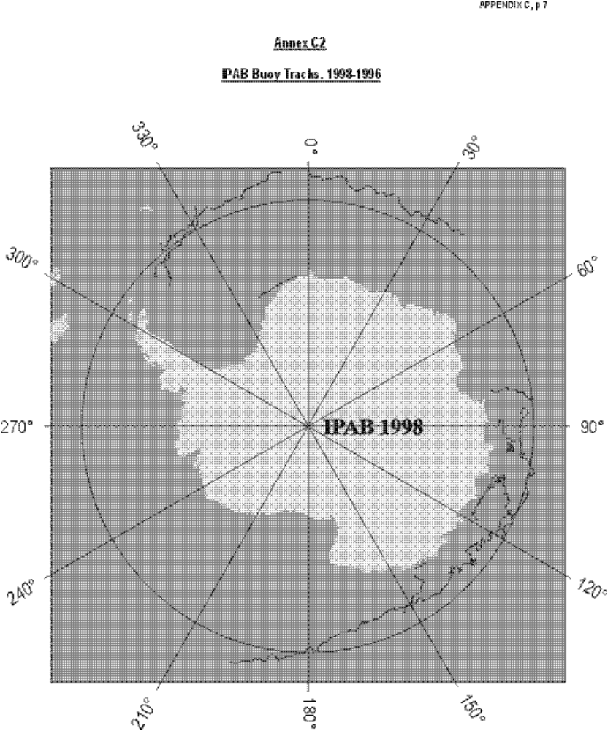
Figure 6.2-39
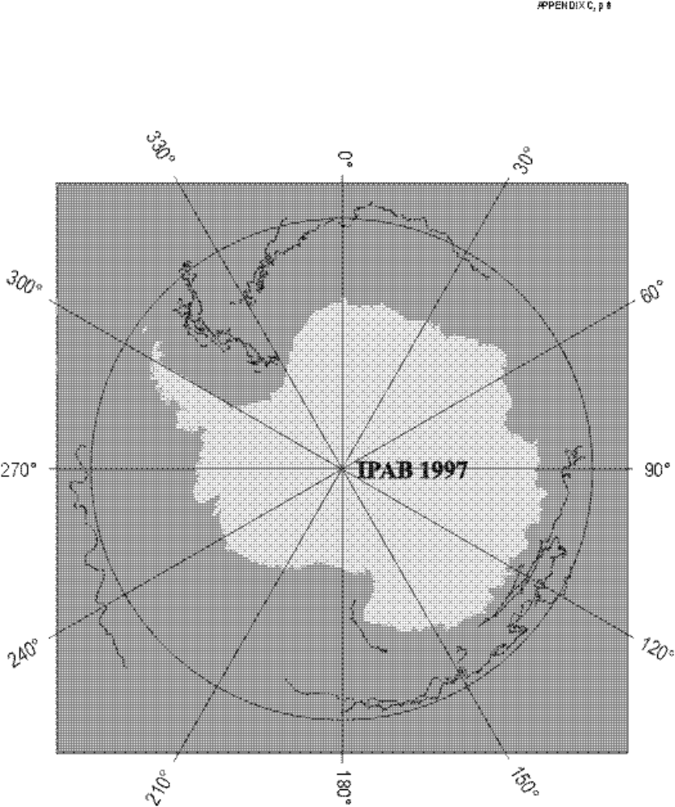
Figure 6.2-40.
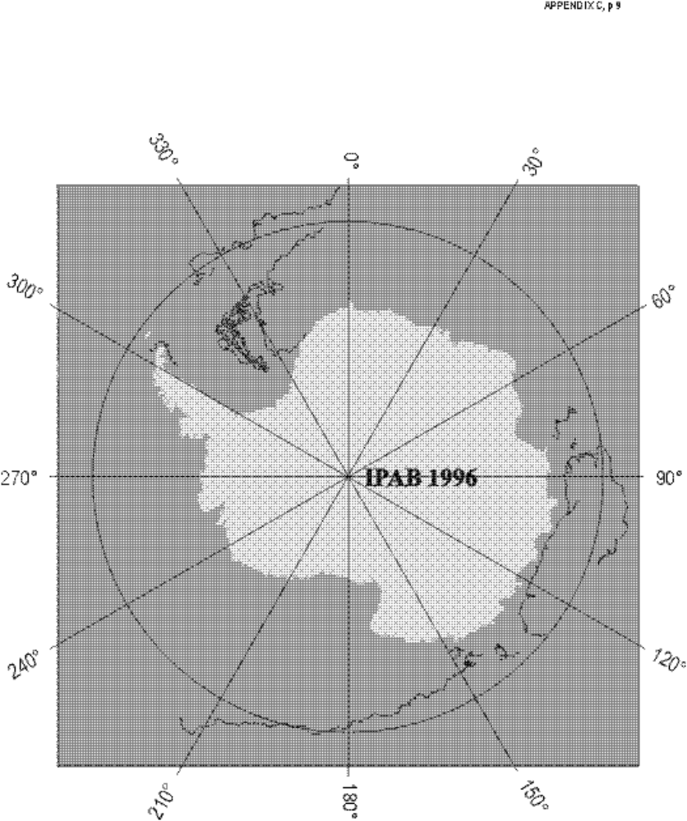
Figure 6.2-41.
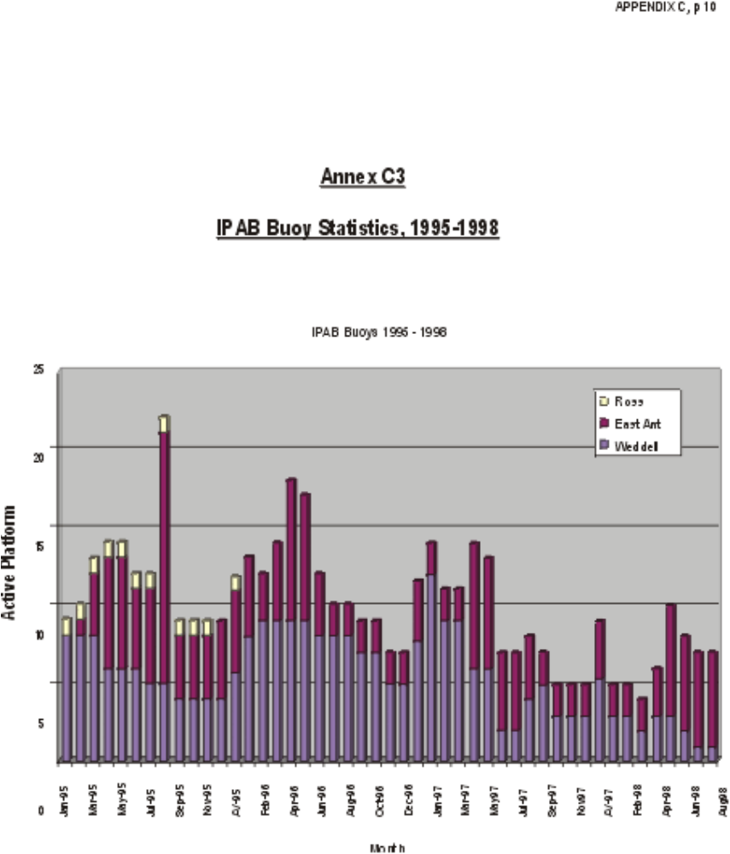
Figure 6.2-42

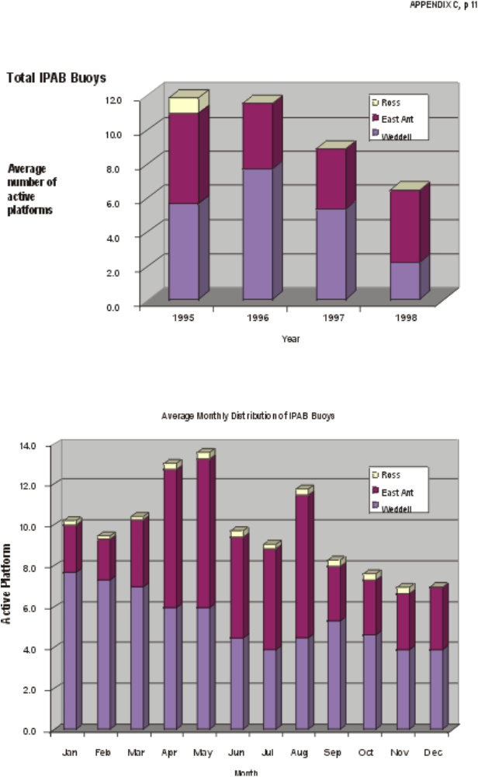
Figure 6.2-43.
Taking into account the need for wider support of the IPAB, the ACSYS SSG-VII (Tokyo, Japan, November 1998) recommended that the WCRP JSC make a formal statement in support of the IPAB encouraging more active participation of the operational meteorological agencies in the program. Annex 1 contains the JSC-XX ( March 1999) statement on the subject.
A footnote added by the editor of the iAnZone-VI report:
Responding to the request of the JSC-XX, the WMO Thirteenth Congress (Cg-XIII, May 1999) gave a strong encouragement to the IPAB. The following is an extract from the section 3.2.7.13 of the Cg-XIII/PINK 3.2.7 document (World Climate Research Program):
" Congress …particularly appreciated the value of the data being collected in the WCRP International Program for Antarctic Buoys (IPAB) , not only to support research in the region, but also in providing valuable operational meteorological data in real-time and establishing a basis for monitoring atmospheric and oceanic changes in the Antarctic sea-ice zone. Congress urged national Meteorological Services having interests in the Southern Ocean and Antarctic to participate actively in IPAB by providing ice-resistant drifting buoys or by other appropriate means".

ANNEX 1
Encouraging participation of National Meteorological Services (NMS) in the WCRP International Program for Antarctic Buoys
Statement by the twentieth session of the Joint Scientific Committee (JSC) for the WCRP
The WCRP International Program for Antarctic Buoys (IPAB) was established in June 1994. IPAB builds upon co-operation among agencies and institutions with Antarctic and Southern Ocean interests to develop and maintain an optimum observational network for near-surface meteorological and oceanographic data within the Antarctic sea-ice zone, using drifter buoys and other appropriate data collection systems. The operational area of the Program is south of 55°S, and includes that region of the Southern Ocean and Antarctic marginal seas within the maximum seasonal sea-ice extent. IPAB has a strong research component, and is endorsed as a self-sustaining project of the WMO/ICSU/IOC World Climate Research Program. IPAB is also an Action Group of the WMO/IOC Data Buoy Co-operation Panel.
The objective of the IPAB is to establish and maintain a network of drifting buoys in the Antarctic sea-ice zone in order to:
- support research in the region related to global climate processes and to global change, and, in particular, to meet research data requirements specified by the WCRP and relevant SCAR programs;
- provide real-time operational meteorological data meeting the quality requirements of the WMO World Weather Watch (WWW) program;
- establish a basis for on-going monitoring of atmospheric and oceanic climate in the Antarctic sea-ice zone, in particular contributing to the aims of GCOS.
The program actually has 19 participating institutions. The IPAB is mainly supported by research agencies, although three National Meteorological Services (NMS) with regional and global interests contribute actively to the program (Bureau of Meteorology, Australia; South African Weather Bureau; Meteorological Office, United Kingdom). IPAB presently maintains an array of 5-15 buoys in the region south of 55°S, all reporting on the GTS in real time. The number of IPAB buoys is obviously not sufficient to meet the requirements of the WWW and the need of the medium range weather forecasting using global models.
Recent research into the impact of surface buoy data on the analysis and forecasts by means of Numerical Weather Prediction Models (Turner et al.: The Antarctic First Regional Observing Study of the Troposphere (FROST) project, Bull. Am. Meteorol. Soc., 1996; Kottmeier et al.: Wind, temperature, and ice motion statistics in the Weddell Sea, WMO/TD-No. 797, 1997) has demonstrated strong potential impact of such drifting buoys on pressure and wind analyses.
WCRP IPAB therefore seeks more commitments from National Meteorological Services which would participate in the program. This mainly concerns the provision of additional buoys and contribution to the Argos transmission costs, whereas the deployment of buoys would be done by research agencies during Antarctic research vessel activities.
The JSC-XX recalled Resolution 11 (WMO EC-XLVI, 1994) "Organization of an International Program for Antarctic Buoys" and confirmed the value of the IPAB data for meeting the WMO World Weather Watch, WCRP and GCOS objectives. The Committee requested the WMO Congress-XIII (May 1999) to urge those National Meteorological Services which have Antarctic and Southern Ocean interests to participate actively in the implementation of the WCRP International Program for Antarctic Buoys by providing ice-resistant drifting buoys, or by other appropriate means.

CLIVAR Southern Ocean
Douglas Martinson
The Implementation Plan of the CLIVAR (Climate Variability and Predictability) project of the World Climate Research Programme (WCRP) presents its issues through a number of Principal Research Areas (PRAs). Of these, most have either a regional or phenomenological emphasis; an organization designed to reflect typical working patterns of our community and the scientific foci of nations in general. Southern Ocean issues of primary importance for most effectively improving our understanding of climate variability and predictability are covered in PRA D5 (Southern Ocean) in the Implementation Plan (which can be viewed on the CLIVAR's web page;
[URL 17] http://www.soc.soton.ac.uk/OTHERS/ICPO
Note that the designator "D" to the chapter containing the Southern Ocean issues highlight the fact that most (though not all) of the issues in this section address decade-to-century (dec-cen) time scale phenomena.
The Southern Ocean PRA targets several issues of primary importance. These are briefly reviewed in the general D5 outline given below (primary recommendations or issues are quoted in boxes).
Finally, there are some new WCRP developments that affect the manner in which Southern Ocean climate-related science issues are distributed amongst WCRP projects; in particular, CLIVAR, the Arctic System Science (ACSYS) project and the new Climate and Cryosphere (CLIC) project. Traditionally, ACSYS has dealt almost exclusively with the issues related to the central Arctic (though that project is home to the Antarctic Buoy program). Recognizing the importance of the entire cryosphere (and general polar processes), the WCRP has recently created the CLIC project. Its purpose is to more explicitly represent all cryospheric issues (note: CLIC will not eliminate ACSYS, rather, when ACSYS reaches its original sunset date in a few years, those ACSYS issues that have not yet been resolved will be adopted by the CLIC project). The CLIC draft Science Plan addresses all cryospheric issues of relevance to climate, regardless of what other WCRP projects might explicitly include them. So, cryospheric issues presented in CLIVAR's D5 are also presented in the CLIC science plan. However, in order to minimize project disruptions and avoid creating angst in the community, it has been agreed that even though CLIC may identify all important cryosphere issues, those currently articulated in other projects will still remain in those projects, addressed by the scientists working on that project. CLIC will merely serve, in those cases, to make sure that ultimately all of the important issues are addressed regardless of which project actually addresses them. In other words, CLIVAR must still work to resolve those cryospheric issues necessary for it to achieve its overall project objectives. [Note that during the Argentina meeting, we discussed rumors that CLIVAR D5 may be eliminated from the CLIVAR project and placed in the CLIC project - this was not true, and the philosophy outlined immediately above was explicitly agreed upon regarding overlapping interests between projects.]

Overview of CLIVAR Implementation Plan Section D5 (Southern Ocean)
The Southern Ocean provides the only deep ocean link between all ocean basins, and thus allows for considerable heat and freshwater transport and propagation of anomalies from one basin to another over variety of time scales. Changes in the strength of the Antarctic Circumpolar Current (ACC) may also be related to changes in THC and hence impact global climate. Despite this importance, understanding of the Southern Ocean circulation and the ACC is rudimentary.

ACC also serves to thermally isolate Antarctic polar waters (and continent) leading to glaciation of continent. Formation of Subantarctic mode waters (SAMW) and intermediate waters (AAIW) ventilates thermocline of Southern Hemisphere on decadal time scales and play major role in CO2 uptake.

AABW cools deep oceans globally and reflects interaction between ocean, ice and atmosphere. Deep convection occurs along continental shelves and via open ocean convection.

Ocean stratification and general dynamics strongly interacts and influences sea ice distribution in space and time. This also influences interaction with glacial ice which influences global sea level (as well as THC characteristics). Abrupt change in this distribution can occur from destabilization of the water column as suggested by the Weddell Polynya.
Models suggest that Antarctic sea ice cover plays a major role in simulated climates, thus its proper representation may prove crucial (e.g., 38% of GISS doubled CO2 simulation was due to change in sea ice, 70% of which occurred in Antarctic).
Southern Ocean in general is source of large data gaps and observational weaknesses, though some coherent climate patterns (e.g., Antarctic Circumpolar Wave and PSA teleconnection).
Subsection 1.8: Scientific Rationale Summary. Central scientific issues center around: (1) ACC; (2) AAIW and SAMW; (3) CDW upwelled in polar oceans (influencing sea ice, glacial ice and atmosphere); (4) AABW; and (5) Antarctic sea ice fields. (14-4)
Need for global, regional and local modeling.
Subsection 4: Observational Strategy. Observational needs include: (1) fluxes across chokepoints; (2) VOS sampling; (3) repeated hydrographic sections; (4) drifters and floats; (5) AABW monitoring; (6) remote sensing of sea ice; (7) snow and ice thickness observations via ASPECT; and, (8) fast ice monitoring. Also, Weddell polynya rapid response program in place to study next polynya. (14-9,-13)

Subsection 5.2: Linkages with Other WCRP Programmes. After noting similarity of many D5 needs to those of ACSYS, it is recommended that CLIVAR will be best served by establishing a coherent atmosphere-ocean-sea ice-glacial ice program for the Southern Ocean within CLIVAR, rather than attempting to graft an Antarctic program onto ACSYS. Good lines of communication between polar oceanographers and sea ice scientists working in the Arctic and Antarctic must be maintained. (14-13)

ARGO Array of profiling floats
Steve Rintoul
In the USA there is a strong initiative to bring a global operational observation system in the framework of the Global Climate Observing System (GCOS) and the Global Ocean Observing System (GOOS) into action which consists of subsurface floats which are located when they return to the sea surface in a regular time sequence (ALACE, APEX). The system ranges under the acronym ARGO (Array for Real-time Geostrophic Oceanography). A Southern Ocean component of ARGO would be highly desirable and possible contributors are encouraged. The floats are potentially measuring and transmitting vertical temperature and salinity profiles which are obtained during the ascend. An "ice strengthened" version of the floats is under developement by Steve Riser. The discussion showed that the potential of this system was recognized. Germany had a first deployment of ALACE in February 1999 in the northern Weddell Sea in the framework of iAnzone 4 Convection. Further contributions are encouraged.

Membership
It was discussed that members of the steering committee should rotate to include a wide group of active scientists into the iAnzone efforts. However, due to the small number of participants a decision about who to rotate has been postponed to the next meeting. There is the problem of funding the participation. Russian scientists need 100% travel support, but WMO does not provide money because iAnZone is not a program supported by WMO.
Arnold Gordon proposed before the meeting to hand the chair to Robin Muench. Eberhard Fahrbach who wishes to step back as a member after this meeting suggested Hartmut Hellmer as cochair. The proposals are supported by the participants and were submitted to SCOR.

Next meeting
Giancarlo Spezie offered to host the next iAnZone meeting #7 on Ischia Island, Italy around 8-13 October 2001 in the context of the 2nd International Conference on the Oceanography of the Ross Sea to be held in Ischia, in October 2001. Web site:
[URL 18] http://antartide.uninav.it

Acknowledgements
We gratefully acknowledge the efforts of our hosts in Argentina to provide a very hospitable and efficient venue for the meeting. In particular we acknowledge Alberto Piola, Servicio Hidrografia Naval, and Raul Guerrero, INIDEP, for their organizational skills and efforts.
In addition, we wish to extend our gratitude to:
CONICET – for a grant to A. Piola in support of meeting activities
INIDEP, Dr. Jorge Cajal, Director, - for meeting facilities,
INIDEP staff
and Maria de Los Angeles Ferrante, University of Mar del Plata, meeting organization and services.

Appendices

Agenda of the 6th iAnZone Coordination meeting

Wednesday, 5 May
Morning:
1 Introduction
2. Local arrangements
3. Review of achievements since last meeting at Biosphere-2
Observations and models in iAnZone projects
a) AnzFlux
b) DOVETAIL
Afternoon:
5. Results from other international and national programs
Observations and models and plans for next few years
USA
Argentina
Australia
Brazil
Finland
Germany
Italy
Norway
Russia
Spain
UK
USA

Thursday, 6 May
Morning:
Status of iAnZone Exp #4 (Convection) planning,
Introduction
1. Slope convection
2. Open Ocean Convection and vertical Fluxes
3. Monitoring Convection Products
Afternoon:
Split into the three working groups to improve international coordination of the three research
streams of "Convection"

Friday, 7 May
Morning:
Coordination with other large Programs
SCOR, ASPeCt,
WCRP:
ACSYS: Antarctic Ice Thickness Program
Antarctic Drifting Buoy Program
CLIVAR Southern Ocean,
CLIC
SCOR -Business
Membership
Next meeting

Afternoon:
DOVETAIL-Workshop organized by R.Muench

Participants of the 6th iAnZone meeting

Drabble, Michael
Instituto Antartico Argentino
Argentina
Ph: 011-54-11-4815-2542
Fax: 011-54-11-4812-2039
E-Mail: oceano@abaconet.com.ar

Fahrbach, Eberhard
Alfred-Wegener-Institut
fur Polar-and Marine Research
Postfach 12 01 61
Columbasstrabe
D-27515 Bremerhaven, Germany
Ph: 011-49-471-4831-1820
Fax: 011-49-471-4831-1797
E-Mail: efahrbach@awi-bremerhaven.de

Ferrante, Maria
Universidad de Mar del Plata
E-Mail: aferran@mdp.edu.ar

Gallo, Jose
Instituto Antartico Argentino
Argentina
Ph: 011-54-11-4815-2642
Fax: 011-54-11-4812-2039
E-Mail: ocean@abaconet.com.ar

Garcia, Marc A.
LIM/Laboratori d'Enginyeria Marítima
UPC
Gran Capità s/n 08034
Barcelona, Spain
Ph: 011-34-9-34016468
Fax: 011-34-9-34016504
E-Mail: GARCIAL@ETSECCPB.UPC.ES

Gordon, Arnold
Lamont-Doherty Earth Observatory
Route 9W
Palisades, New York 10964
Ph: 914-365-8325
Fax: 914-365-8157
E-Mail: agordon@
ldeo.columbia.edu

Guerrero, Raul
INIDEP
Pje. Victoria Ocampo 1
Mar del Plata, Argentina
Ph: 011-54-223-4861292
E-Mail: guerrero@lisa.inidep.edu.ar

Hellmer , Hartmut
Alfred-Wegener-Institut
fuer Polar- und Meeresforschung
Postfach 12 01 61
Columbusstrasse
D-27515 Bremerhaven, Germany
Ph: 011-49-471-4831-1794
Fax: 011-49-471-4831-1797
E-Mail: hhellmer@awi-bremerhaven.de

Huber, Bruce
Lamont-Doherty Earth Observatory
Route 9W
Palisades, New York 10964
Ph: 914-365-8329
Fax: 914-365-8157
E-Mail: bhuber@ldeo.columbia.edu

Lettau, Bernhard
National Science Foundation
Office of Polar Programs
4201 Wilson Boulevard
Arlington, Virginia 22230
Ph: 703-306-1045
Fax: 703-306-0139
E-Mail: blettau@nsf.gov

Martinson, Douglas
Lamont-Doherty Earth Observatory
Route 9W
Palisades, New York 10964
Ph: 914-365-8830
Fax: 914-365-8736
E-Mail: dgm@ldeo.columbia.edu

Martos, Patricia
Universidad de Mar del Plata
Funes 3250
Mar del Plata, Argentina
E-Mail: pmartos@mdp.edu.ar

McPhee, Miles
McPhee Research Company
450 Clover Springs Road
Naches, WA 98937
Ph: 509-658-2575
E-Mail: miles@apl.washington.edu

Muench, Robin
Earth & Space Research
1910 Fairview East, #102
Seattle, Washington 98102-3620
Ph: 206-726-0522
Fax: 206-726-0524
E-Mail: rmuench@esr.org

Nuñez, Mario
Centro del Inv.
Del Mar yla Atmosfera
Argentina
Ph: 011-54-114-787-2693
Fax: 011-54-114-788-3572
E-Mail: mnunez@at1.fcen.uba

Orsi, Alex
Texas A & M University
Dept. of Oceanography
College Station, Texas 77843-3146
Ph: 409-845-4014
Fax: 409-847-7789
E-Mail: alex@bonito.tamu.edu

Piola, Alberto
Depto. Oceanografia
Servicio de Hidrografia Naval
Avda. Montes de Oca 2124
1271 Buenos Aires, Argentina
Ph: 011-54-1301-3091
Fax: 011-54-1303-2299
E-Mail: apiola@rina.hidro.gov.ar

Reta, Raul
Universidad de Mar del Plata
Argentina
E-Mail: reta@mdp.edu.ar

Rintoul, Steve
Antarctic CRC
GPO Box 252C
Hobart
Tasmania 7001, Australia
Ph: 011-61-3-6232-5393
Fax: 011-61-3-6232-5123
E-Mail: Rintoul@ml.csiro.au

Savtchenko, Victor
Office-World Climate Research Programme
c/o World Meteorological Organization
41 av. Guiseppe-Motta
C.P. 2300
Geneva CH-1211, Switzerland
Ph: 011-41-22-7308486
Fax: 011-41-22-7308536
E-Mail: savtchenko_V@gateway.wmo.ch

Schlosser, Peter
Lamont-Doherty Earth Observatory
Route 9W
Palisades, New York 10964
Ph: 914-365-8707
Fax: 914-365-8155
E-Mail: peters@ldeo.columbia.edu

Spezie, Gian Carlo
Instituto Universitario Navale
Facaltá De Scienze Nautiche
Cattedra Di Oceanografia
Via Amm. I. Acton 38
I-80133 Napoli, Italy
Ph: 011-39-08-5475586
Fax: 011-39-08-5513157
E-Mail: spezie@naval.uninav.it

Draft Agenda for the 2000 International DOVETAIL workshop to be held in Barcelona, Spain
Draft agenda for international DOVETAIL program workshop
Tuesday 2 May - Thursday 4 May, 2000
Barcelona, Spain
[ additional information and updates available on the web at
[URL 19] http://www.ldeo.columbia.edu/physocean/Dovetail/barcelona2000.html
DAY 1
0900-0915 Introduction (Muench)
0915-1045 Large-scale circulation & hydrography (discussion leader - Muench)
0915-1000 Winter 97 regional results (Visbeck)
1000-1045 Bransfield results (Garcia/Blade/Visbeck)
1045-1115 Coffee break
1115-1300 Large-scale circulation continued (discussion leader - Orsi)
1115-1200 WOCE line and other UK results (Heywood/McDonagh/Naveira-Garabata)
1200-1300 Results from German cruises & moorings (Hellmer/Schroeder/von Gyldenfeldt)
1300-1430 Lunch break
1430-1600 Large-scale circulation continued (discussion leader - Heywood)
1430-1515 Chemistry and tracer results (Schlosser/Smethie/)
1515-1600 General discussion of large-scale field results
1600-1630 Coffee break
1630-1800 Mixing and upper ocean processes from field measurements (discussion leader - Garcia)
1630-1715 Boundary layer & tidal mixing (Visbeck/Muench)
1715-1800 Upper ocean processes (Muench (including Martinson work))
1800 Adjourn for day
DAY 2
0900-1045 Modeling issues (discussion leader - Visbeck)
0900-1000 Results from AWI model (Hellmer/Schodlok)
1000-1045 Results from OSU model (Matano)
1045-1115 Coffee break
1115-1300 Modeling issues continued (discussion leader - Schlosser)
1115-1145 Upper ocean model (Muench (for Martinson))
1145-1300 General discussion of models & validation issues
1300-1430 Lunch break
1430-1510 Ongoing programs (discussion leader - Muench)
1430-1440 US current measurement program (Visbeck)
1440-1510 Brazilian shipboard program (Hellmer)
1510-1600 Coordination (discussion leader - Muench)
1430-1500 Ongoing program collaborations
Topics for specific "primary" papers.
Data exchange and databank.
1600-1630 Coffee break
1630-1800 Coordination continued
Breakout groups discuss details of work on specific topics.
1800 Adjourn for the day
2000 - Organized dinner
DAY 3
Morning is reserved for unfinished business, pending additions and corrections to this draft
plan.

ANZFLUX Publications
Cherkaeva, E., and K. M. Golden. Inverse bounds for microstructural parameters of composite media derived from complex permittivity measurements, Waves in Random Media, 8(4), pp. 437-450, 1998.
Fisher, R. and V.I. Lytle, Atmospheric Drag Coefficients of Weddell Sea Ice computed from Roughness Profiles, Annals of Glaciology Vol 27, 455-460, 1998
Golden, K. M. , The interaction of microwaves with sea ice, in Wave Propagation in Complex Media, IMA Volumes in Mathematics and its Applications, Vol. 96, G. Papanicolaou, ed., Springer-Verlag, pp. 75-94, 1997.
Golden, K. M., S. F. Ackley and V. I. Lytle, The percolation phase transition in sea ice, Science, 282, pp. 2238-2241, 1998.
Guest, P. S., Surface longwave radiation conditions in the eastern Weddell Sea during winter, J. Geophys. Res., 103, 30,761-30,771, 1998.
Hohmann, R., P. Schlosser, B. Huber, 3He And Dissolved Oxygen Balances in the Upper Waters of the Weddell Sea: Implications for Oceanic Heat Fluxes, submitted J. Geophys. Res, 1998.
Martinson, D.G., and R. Iannuzzi, Antarctic Ocean-ice Interaction: Implications From Ocean Bulk Property Distributions In The Weddell Gyre, in Antarctic Sea Ice and Processes (M. Jeffries, ed.), 1998.
McPhee, M. G., Scales of Turbulence and Parameterization of Mixing in the Ocean Boundary Layer, J. Mar. Systems, 21, 55-65, 1999.
McPhee, M. G., Marginal thermobaric stability in the ice-covered upper ocean over Maud Rise, in press, J. Phys. Oceanogr., Aug, 2000.
McPhee, M. G., S. F. Ackley, P. Guest, B. A. Huber, D. G. Martinson, J. H. Morison, R. D. Muench, L. Padman, and T. P. Stanton, 1996. The Antarctic Zone Flux Experiment, Bull. Am. Met. Soc., 77, 1221-1232.
McPhee, M. G., C. Kottmeier, and J. H. Morison, Ocean Heat Flux in the Central Weddell Sea during Winter, J. Phys. Oceanogr., 29, 1166-1179, 1999.
Muench, R., J.H. Morison, L. Padman, D. Martinson, P. Schlosser, B. Huber & R. Hohmann, Maud Rise Revisited, submitted, J. Geophys. Res.
Padman, L., R. Muench, and E. Fahrbach, Cabbeling Catastrophes, submitted J. Geophys. Res. 1998
Padman, L., and C. Kottmeier, High-Frequency Ice Motion and Divergence in the Weddell Sea, J. Geophys. Res., 105, 3379-3400, 2000.
Rapley, M. and V. I. Lytle, Winter flooding of sea ice in the Weddell Sea, Annals of Glaciology Vol 27, 461-465, 1998.

List of websites cited

[URL 1] http://www. ldeo.columbia.edu/physocean/ianzone.
[URL 2] http://www.ldeo.columbia.edu/physocean/Dovetail/barcelona2000.html.
[URL 3] http://www.ldeo.columbia.edu/physocean/proj_Dove.html
[URL 4] http://www.mth.uea.ac.uk/ocean/ALBATROSS/
[URL 5] http://www.nerc.ac.uk/ms/Autosub/
[URL 6] http://www.ldeo.columbia.edu/physocean/ianzone/project_4/index.html
[URL 7] http://www.awi-bremerhaven.de/Research/ansitp/index.html
[URL 8] http://www.ldeo.columbia.edu/physocean/ianzone/project_4/index.html
[URL 9] http://www.antcrc.utas.edu.au/scar/
[URL 10] http://www.npolar.no/acsys/
[URL 11] http://www.awi-bremerhaven.de/Research/ansitp/index.html
[URL 12] http://www.antcrc.utas.edu.au/antcrc/buoys/buoys.html
[URL 13] http://www.npolar.no/acsys/CLIC/statement.htm
[URL 14] http://www.npolar.no/acsys/CLIC/clic_initiative.htm
[URL 15] http://www.npolar.no/acsys/CLIC/clic_draft.htm
[URL 16] http://www.npolar.no/acsys/CLIC/clic_draft.pdf
[URL 17] http://www.soc.soton.ac.uk/OTHERS/ICPO
[URL 18] http://antartide.uninav.it
[URL 19] http://www.ldeo.columbia.edu/physocean/Dovetail/barcelona2000.html

